

Table of Contents

**1.0 Acknowledgement** 4

**2.0 Gantt Chart** 5

**3.0 Introduction** 6

3.1 Objectives of the project 6

**4.0 System Design** 7

4.1 Wireframes 7

**4.1.1 Guest** 7

**4.1.2 Logged in** 14

4.2 Navigational structure 26

4.4 Database related diagrams 28

4.5 Site Focus stating objectives to the site using the PHP principles 29

4.6 Justification of style design choice and targeted audience 29

**5.0 Functionalities** 30

5.1 Search 30

**GET value** 31

5.2 Login 33

5.3 Add to cart and buy 35

**Update quantity** 37

**Make payment** 38

5.4 Submitting Feedback form 40

5.5 Register 42

5.6 Submitting forgot password form 44

5.7 Edit profile 47

5.8 Track order 50

**Rating** 51

5.9 Seller upload product for selling 52

**Image uploading** 54

5.10 Seller manage product 55

5.11 Manage order 56

5.12 Admin ban sellers or products 57

5.13 Admin preview and reply site feedbacks from users 59

5.14 Admin send link for resetting password 61

5.15 Resetting password 62

5.16 Database connectivity 63

5.17 Logout 63

5.18 MD5 security 64

5.19 Forms pop-up 64

**6.0 Main section (User guidance & sample screen)** 65

6.1 Home page (not yet logged in) 65

6.2 Login form (pop-up) 65

6.3 Register form (pop-up) 66

6.4 Forgot password form (pop-up) 66

6.5 Side navigation bar 67

6.6 Home page (buyer logged in) 68

6.7 Search result page 68

6.8 Seller page 69

6.9 Product page 69

6.10 Shopping cart pop-up (buyer) 70

6.11 Checkout page (buyer) 70

6.12 Edit profile (buyer, seller, admin) 71

6.13 Track order (buyer) 72

6.14 About us page 72

6.15 Help and contact page 73

6.16 Home page (seller) 73

6.17 Selling page (seller) 74

6.18 Manage product page (seller) 74

6.19 Manage order page (seller) 75

6.20 Home page (admin) 76

6.21 Ban page (admin) 76

6.22 Site feedback page (admin) 77

6.23 Forgot password requests page (admin) 77

**7.0 References** 78

# **1.0 Acknowledgement**

I would like to express my very great appreciation to Mr. Syed Mohd Zahid Bin Syed Zainal Ariffin for his valuable and constructive suggestions during the planning and development of this research work. His willingness to give his time so generously has been very much appreciated.

# **2.0 Gantt Chart**

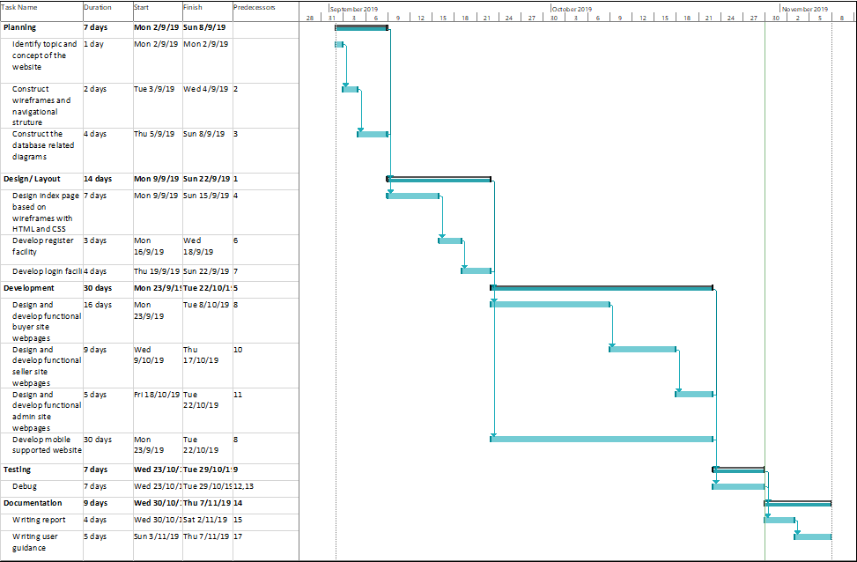

# **3.0 Introduction**

The topic I chosen for the web application is peer-to-peer buy and sell system. Peer-to-peer buy and sell system is basically a system allow people selling their products on the system and people buying products from the people who sell their products on the system which act as a buy and sell platform similar to eBay and Lazada. The login system is a must in this proposed website. All the user having the same login page, as they login the system will recognize them based on their user type. If the user recognizes as admin it will go to the admin page, else if it is seller user it goes to seller webpages else it goes to usual webpages. The responsibility of admin is to approve the product that submitted by seller and the promotions conducted by seller. There would be a searching bar in the website to allow user looking for their interest products based on keywords or category. And rating system is also included in my proposed webpage, users can rate the products they bought. There is also a shopping cart system. This documentation is written about the report, system design, implementation, code snippets and user guidance of the built website.

## 3.1 Objectives of the project

In this project, the objectives of the project are to make a website that a database technology must be used, and the web server application should be able to perform create, read, update and delete together with login functionality to access the page. These objectives are achieved by allowing users logged in as different types of user and different functions can be performed according to the user type. For buyers, they can add or remove products to or from cart and buy products from other sellers and track their orders. For sellers, they can upload their products for selling and manage their uploaded product, not only these and also update the order status for buyers who bought their products. For admin, they can ban any sellers and products which are offensive to other users, admin can also view the queries submitted by the users and reply via email. And requests from the users for resetting their password are also viewable in admin page and the reset password links are send to users’ email. All users are allowed to edit their profile after the registration. All of these functions are using insert, update, delete and select statement of structure query language, SQL and data are stored and retrieved from the database.

# **4.0 System Design**

## 4.1 Wireframes

### **4.1.1 Guest**

The following webpages are pages that allowed any users access to them without login.

Index:

An index, which usually known as home page and it is the head of the website. It contains some information of sale, seller, about us and help & contact so that users don’t miss out these information.

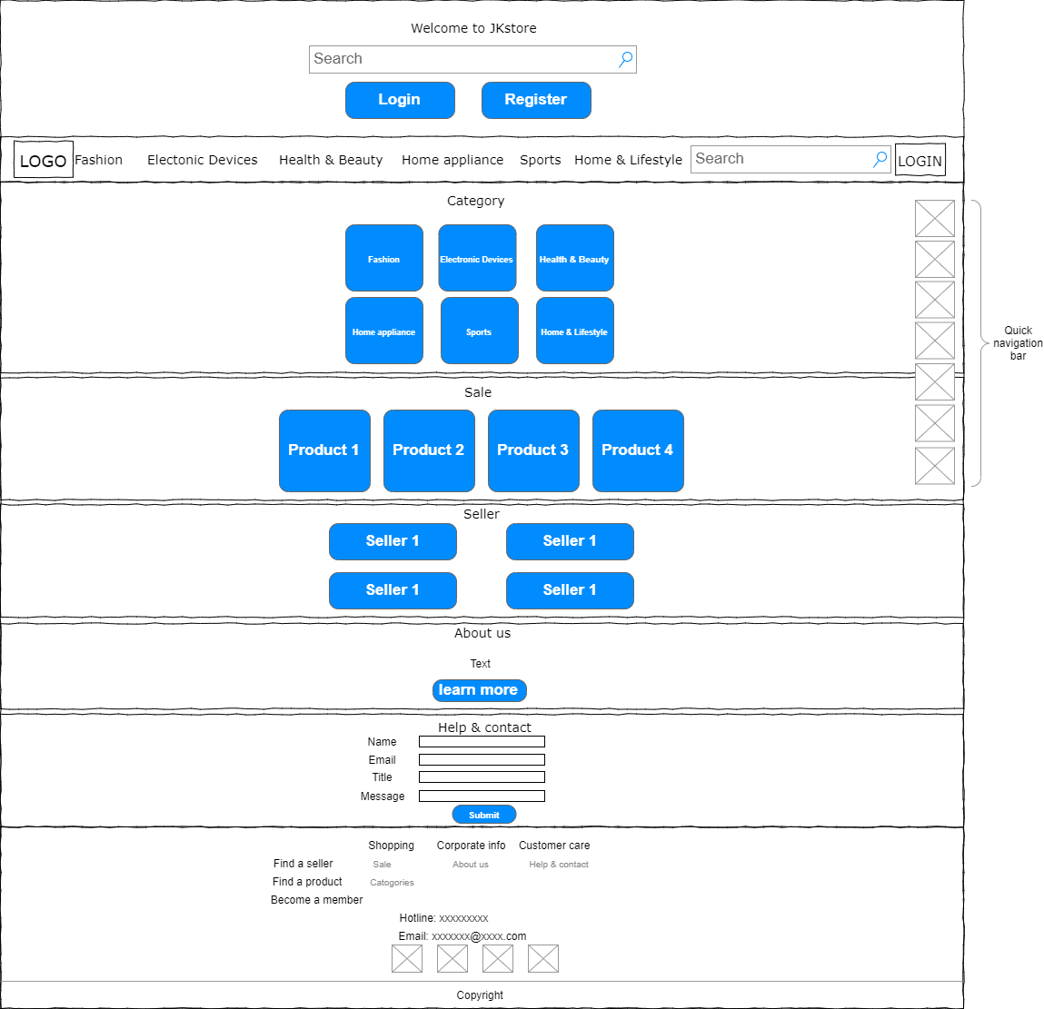

Diagram 1: wireframe of index page

Search results:

Search results page is a web page that redirected after the users searching for some keywords in search bar or by clicking categories on the header or the footer or clicking the ‘see more’ button in index. It shows the results based on the keywords and it is ordered by sellers at top and products at bottom.

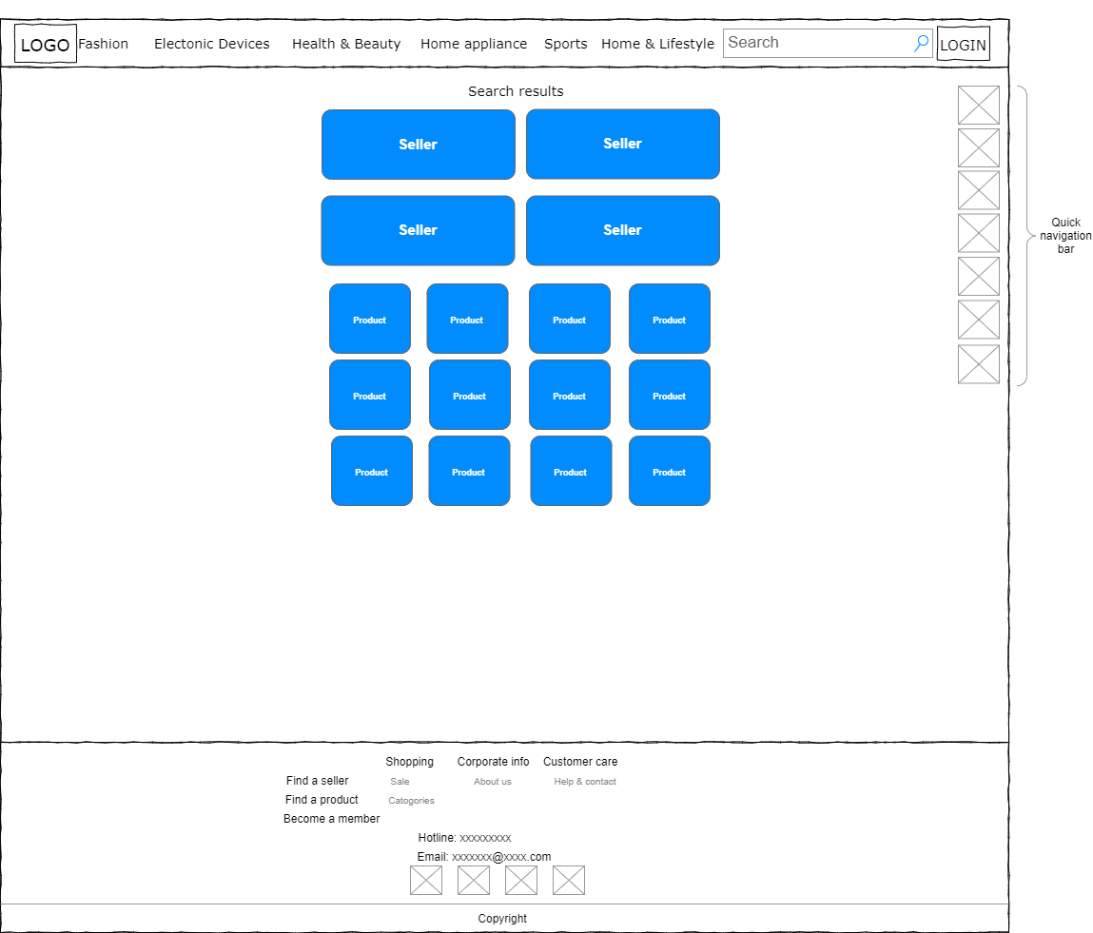

Diagram 2: wireframe of search result

Product page:

Product page is a webpage that only shows one specific product information and allow the users perform add cart and buy actions to the product.

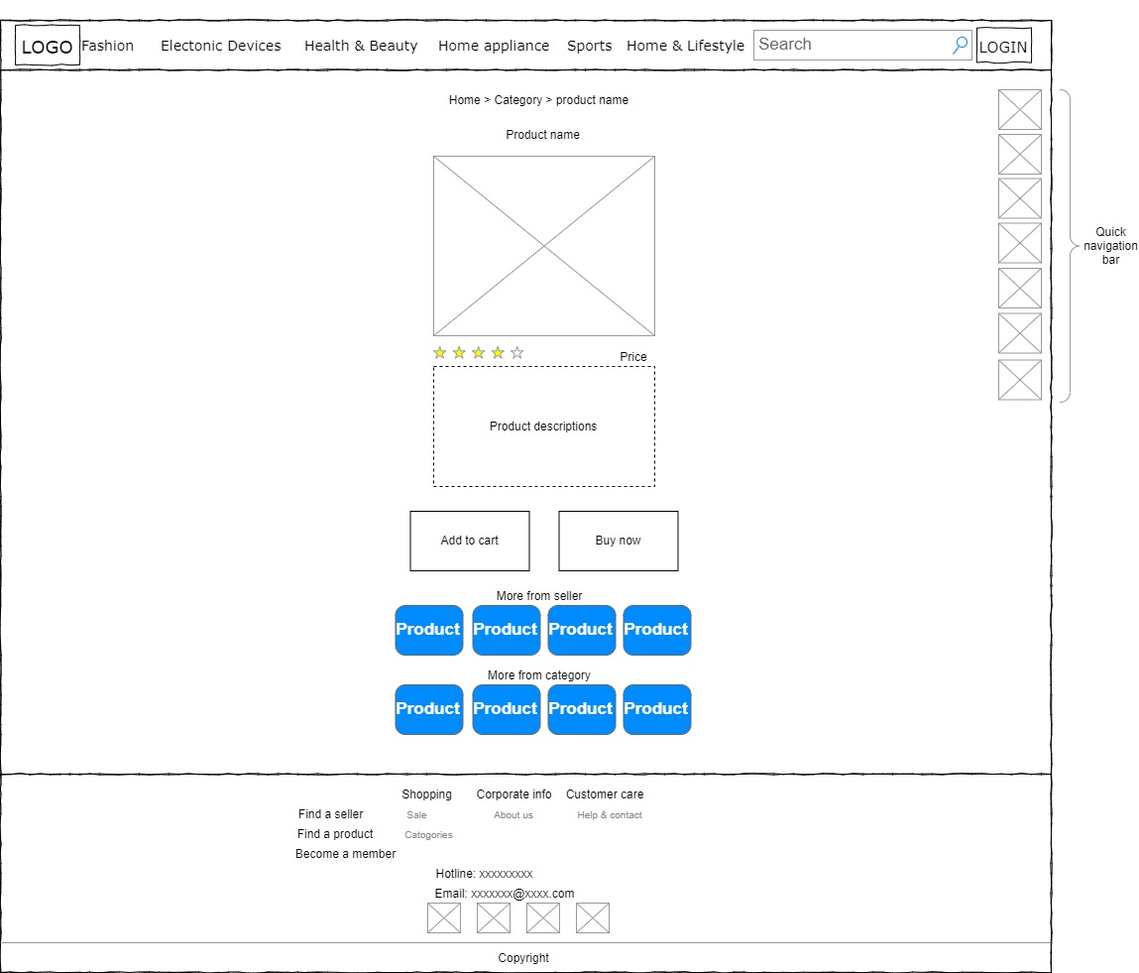

Diagram 3: wireframe of product page

Seller page:

Seller page is the web page that shows only one specific seller with their details and their selling products.

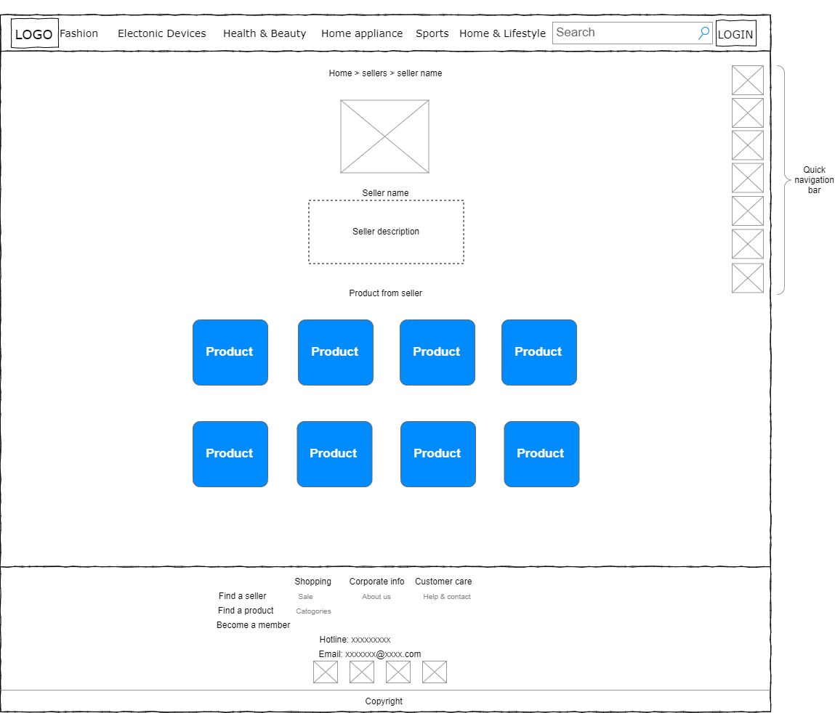

Diagram 4: wireframe of Seller page

About us:

About us web page is the page that shows the corporate information of JKstore.

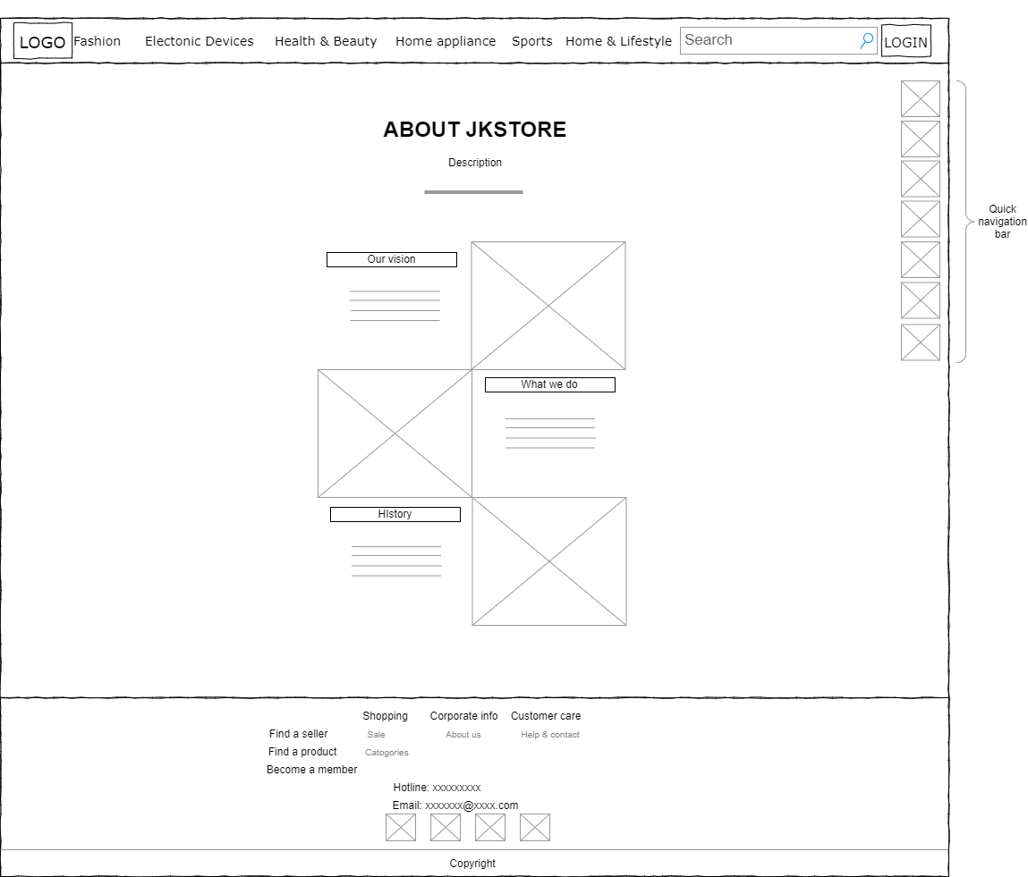

Diagram 5: wireframe of about us

Help and contact:

In this web page, the users are allowed to give complain or feedback to the system.

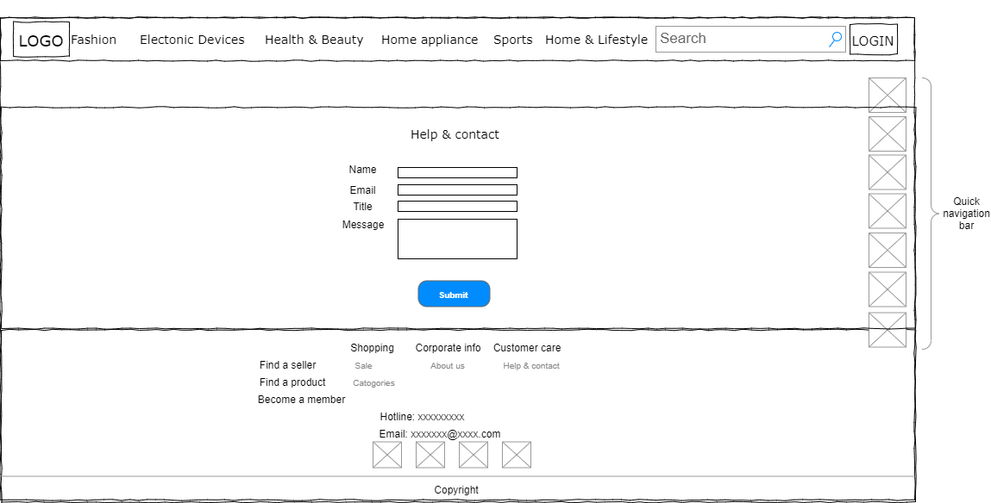

Diagram 6: wireframe of help and contact page

Pop-up forms:

These forms will be showed up when the users perform click on specific buttons.

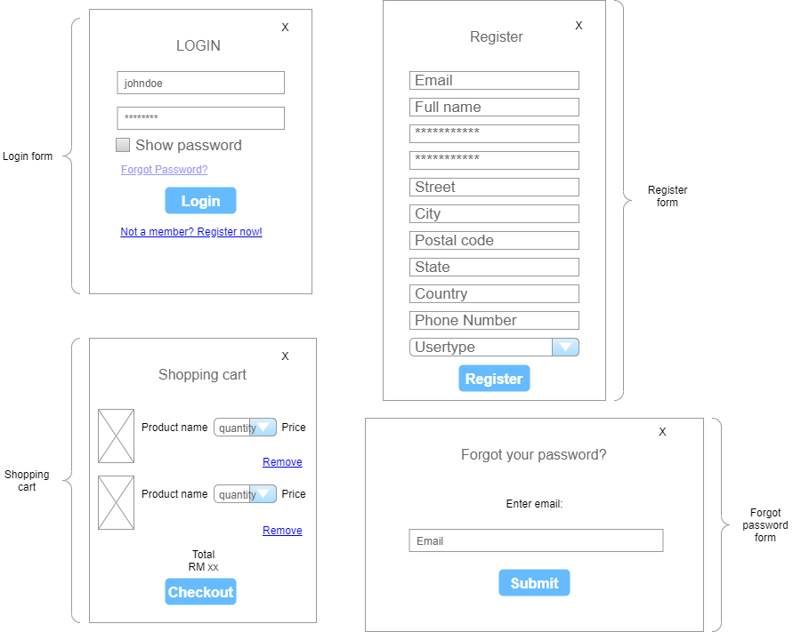

Diagram 7: wireframes of the pop-up forms in the proposed web application

### **4.1.2 Logged in**

For the following webpages, all these webpages are only allowed to access after login.

Edit profile (all user roles):

This web page is to allow users to edit or update their user profile. The edit profile page in admin and seller sites are look exactly same user interface as buyer site, the only difference is there is extra information editable for seller site but less information editable in admin site.

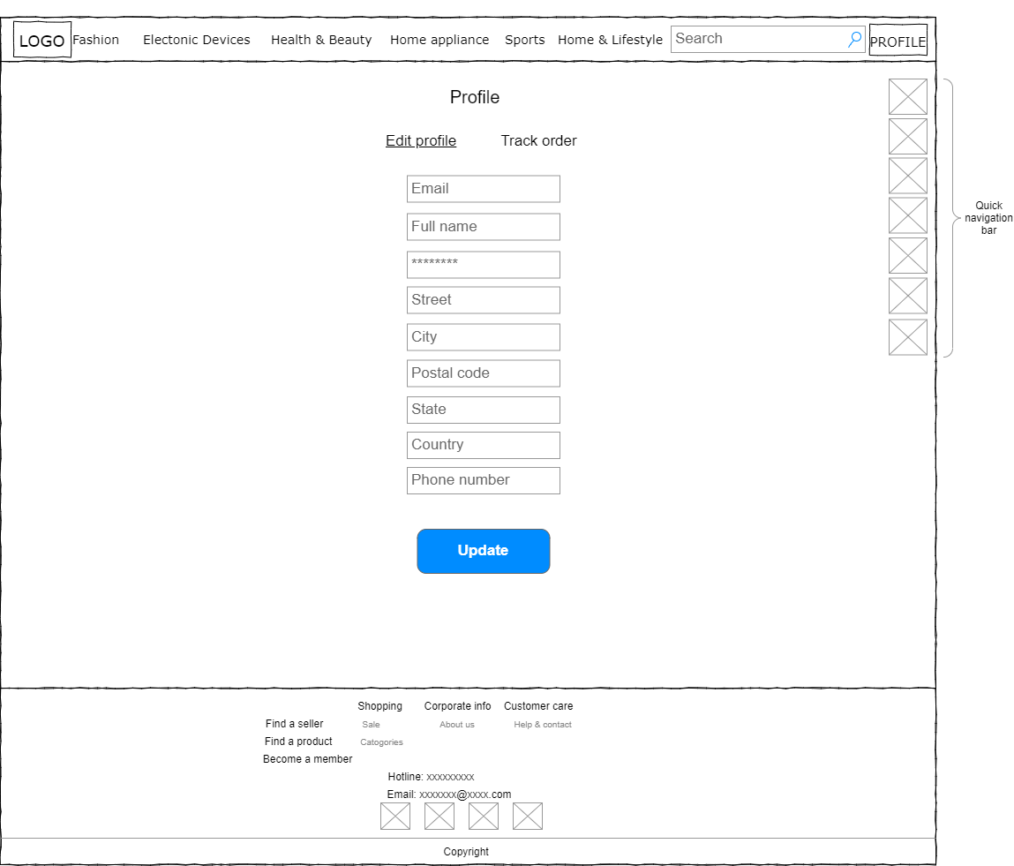

Diagram 8: wireframe of edit profile page (all user role)

#### Buyer

The following webpages are only allowed for users with user role of buyer.

Track order:

This webpage is for buyer to track their purchased orders and the shipping status. Once the product is delivered the buyers are allowed to give rating on the specific products.

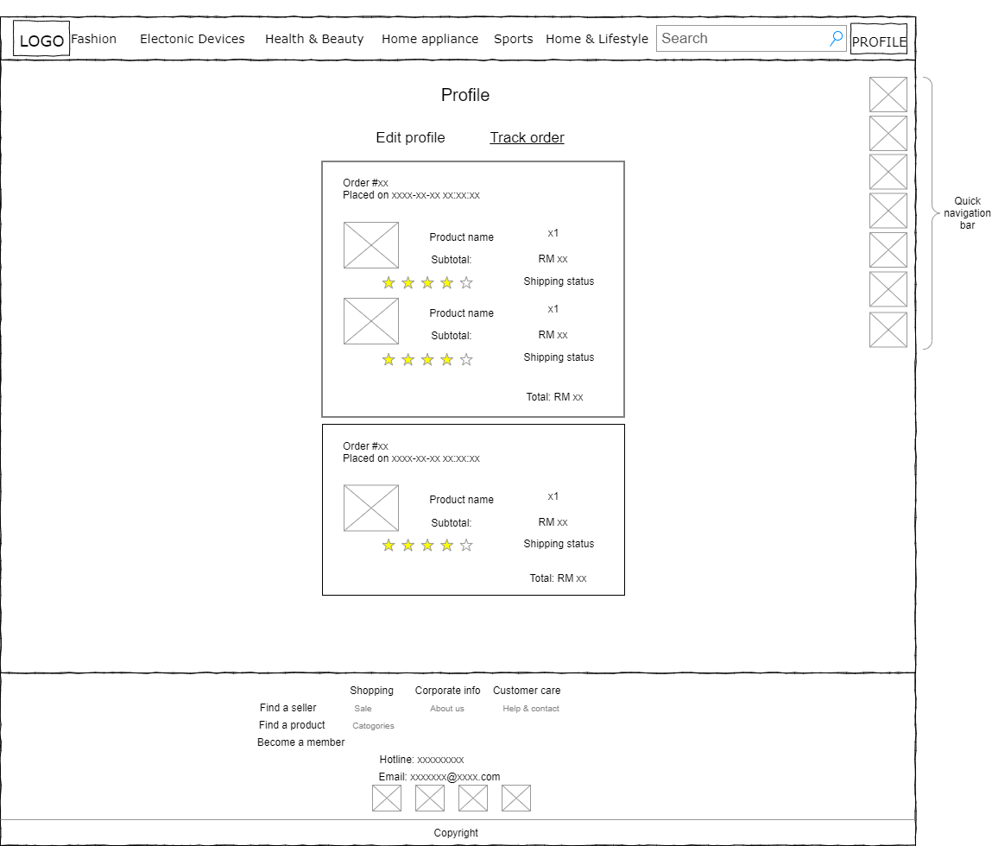

Diagram 9: wireframe of track order

Checkout page:

Checkout page is a webpage for buyer to make their payment.

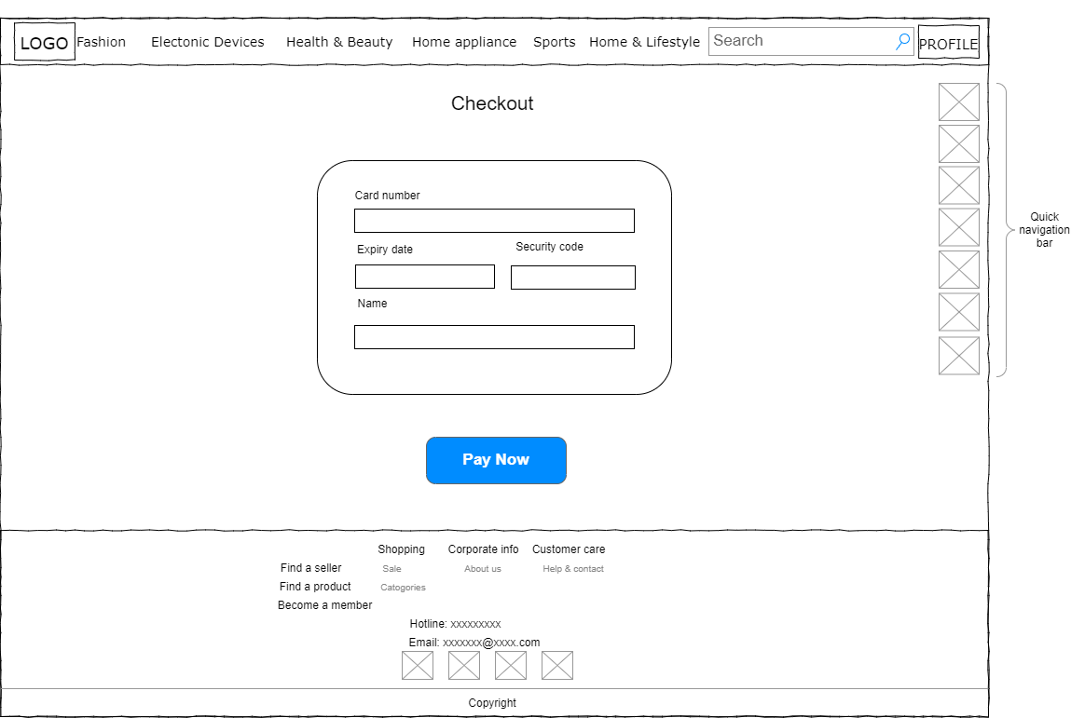

Diagram 10: wireframe of checkout page

#### Seller

For the following webpages, only users with user role of seller can gain access to.

Seller index:

This is the dashboard for sellers.

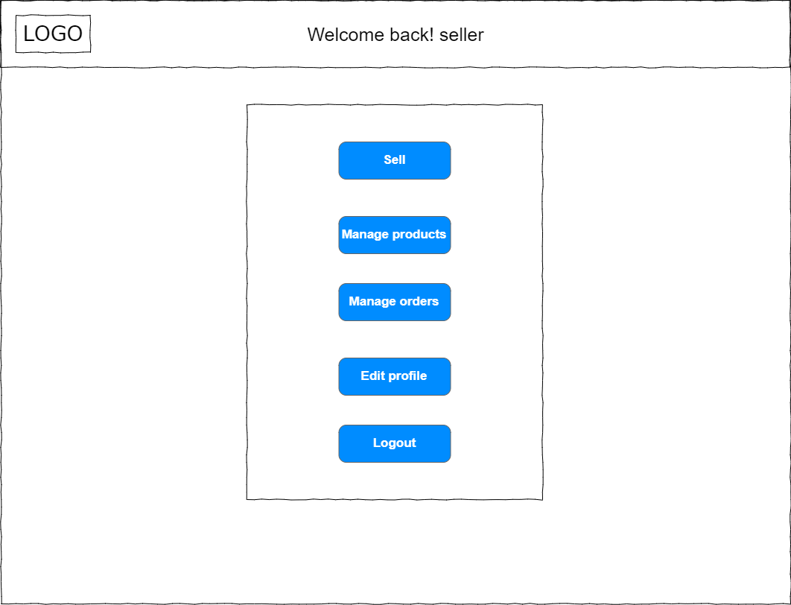

Diagram 11: wireframe of seller index page

Sell page:

In this page, sellers are allowed to submit their product for selling.

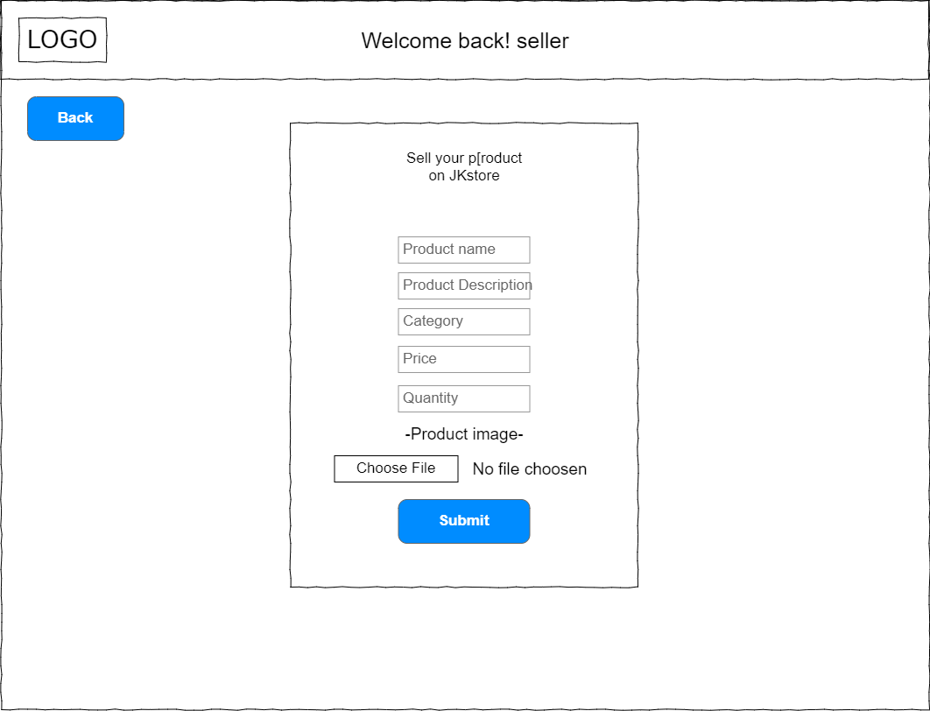

Diagram 12: wireframe of sell page

Manage products:

In this webpage, the sellers are allowed to modify their existing products’ details or make discount for their products.

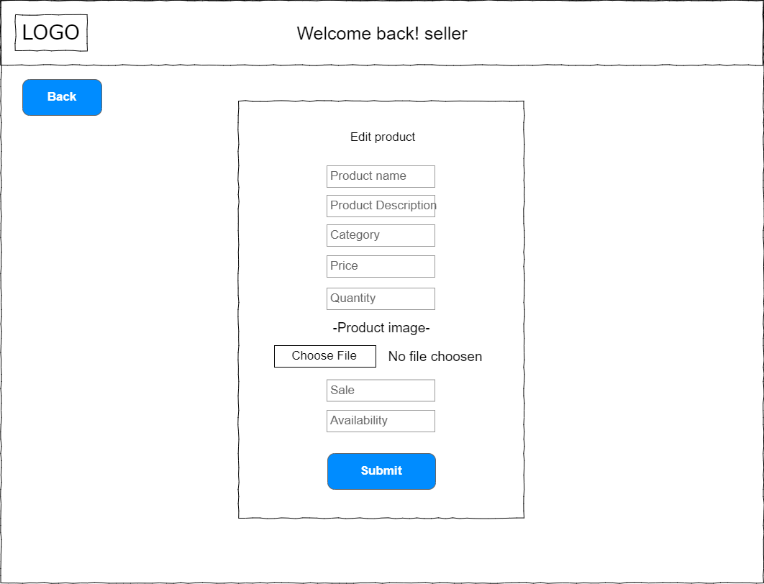

Diagram 13: wireframe of manage products

Manage orders:

In this webpage, seller can update the shipping status for buyers who bought their products.

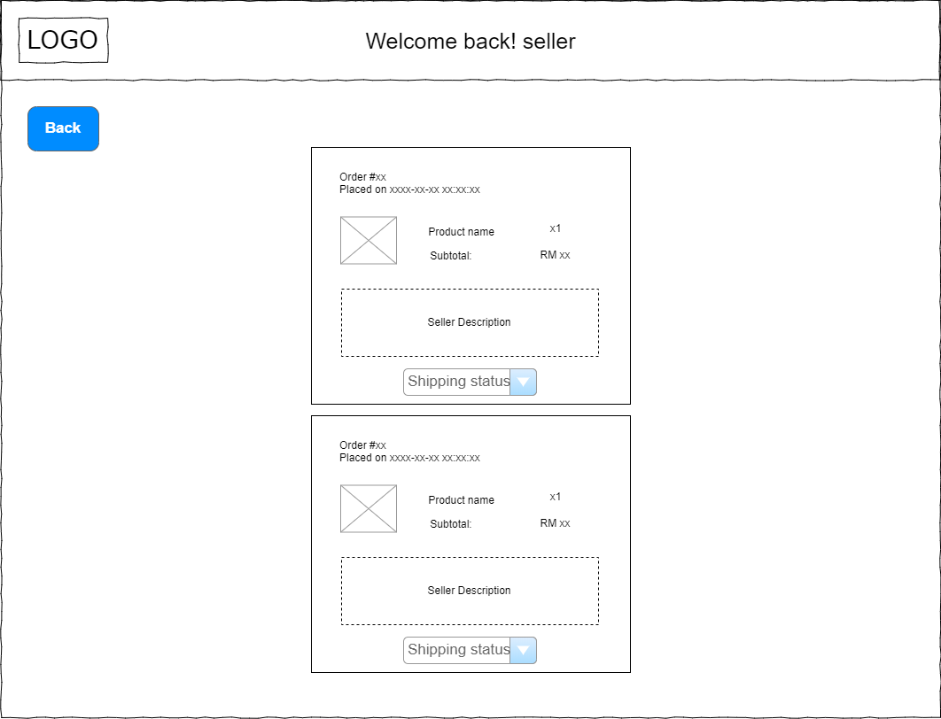

Diagram 14: wireframe of manage orders

#### Admin

The following webpages are only accessible for users with admin role.

Admin index:

This is the dashboard for admin.

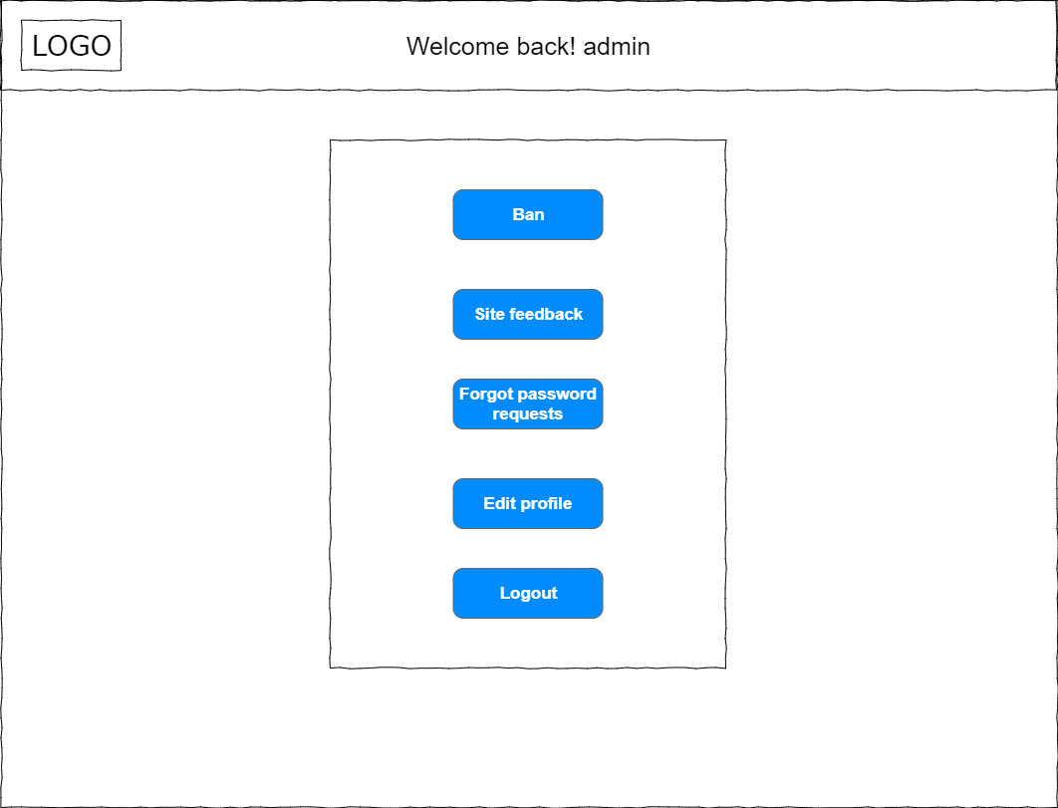

Diagram 15: wireframe of admin index page

Admin ban page:

In this webpage, admin get to choose which sellers or products he/she want to ban.

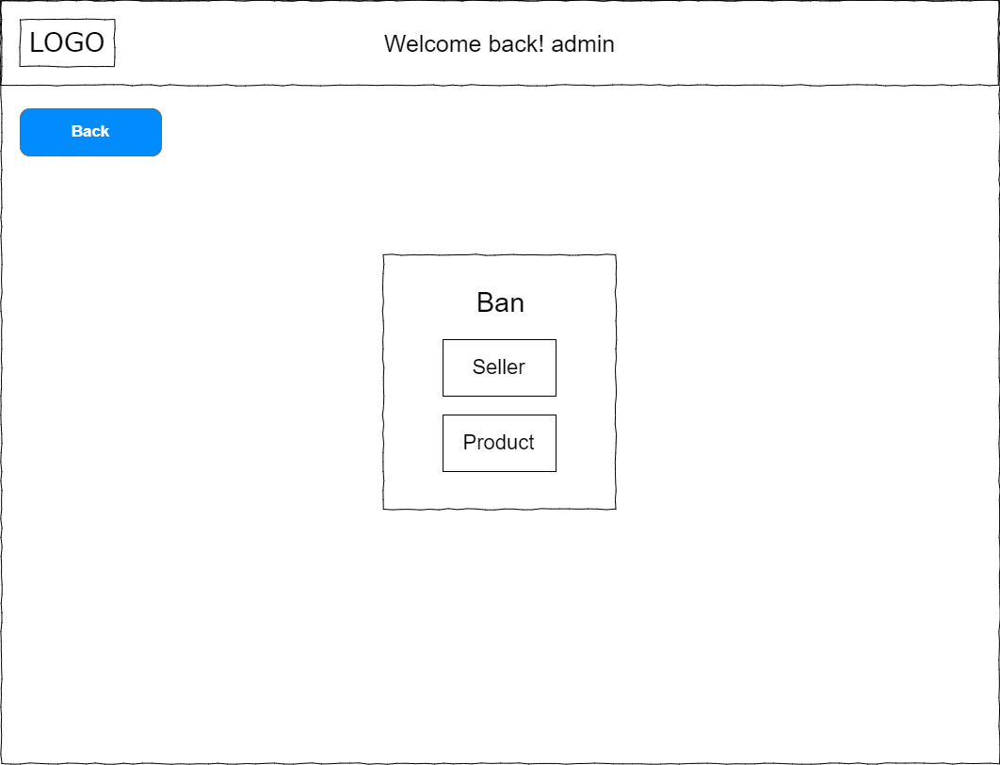

Diagram 16: wireframe of admin ban page (selection page)

After choosing seller/product, it will proceed to this webpage and the admin can ban the sellers or products which are offensive to other users.

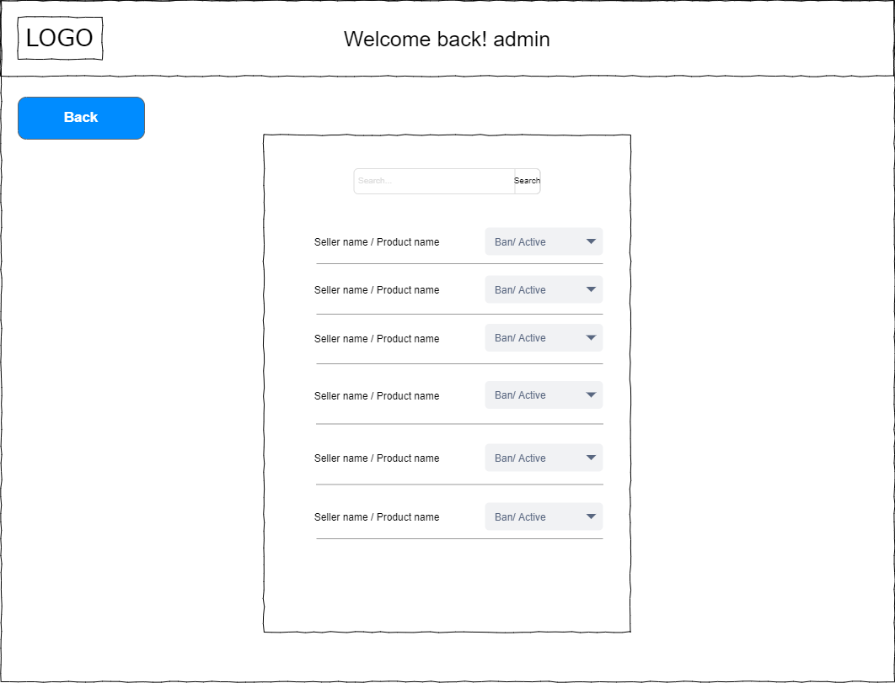

Diagram 17: wireframe of admin ban page (seller/product list)

Site feedbacks preview:

In this webpage, admin can preview the feedback by other users and reply by clicking reply to email them.

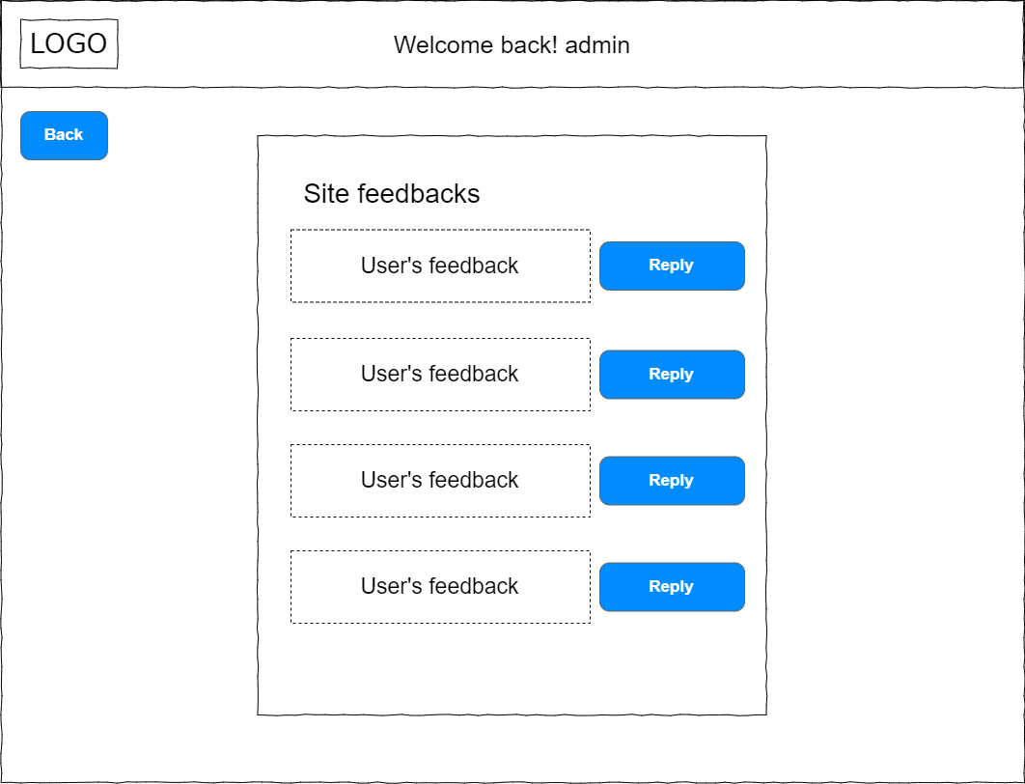

Diagram 18: wireframe of site feedbacks preview

Forgot password requests:

Admin can see the users who requested for resetting their password and send them a reset password link via email by clicking send.

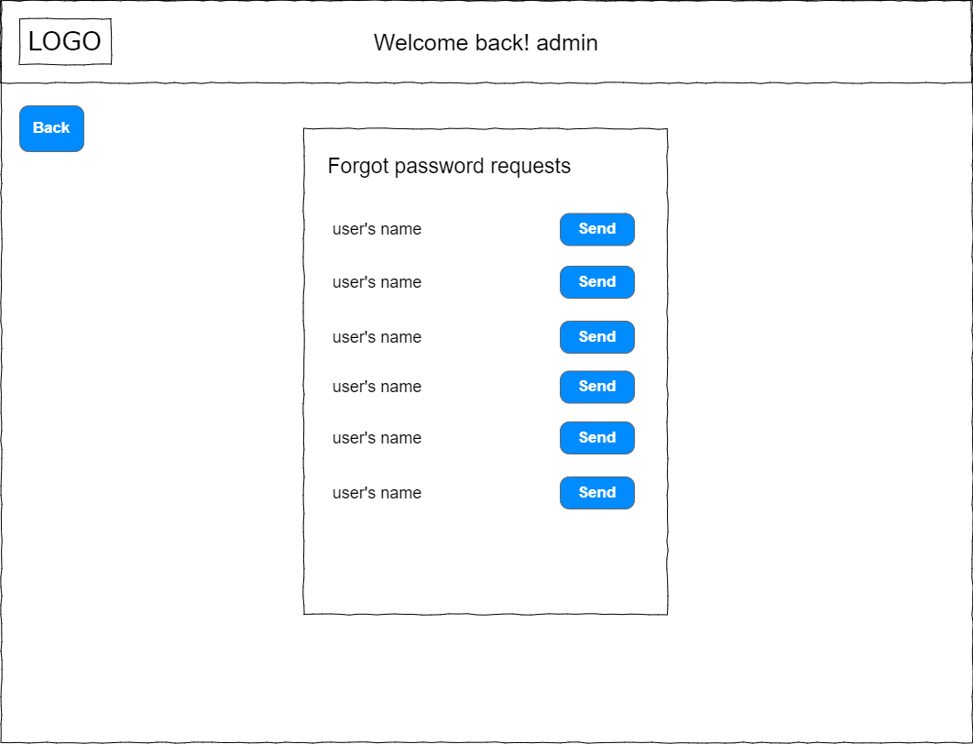

Diagram 19: wireframe of forgot password requests

## 4.2 Navigational structure

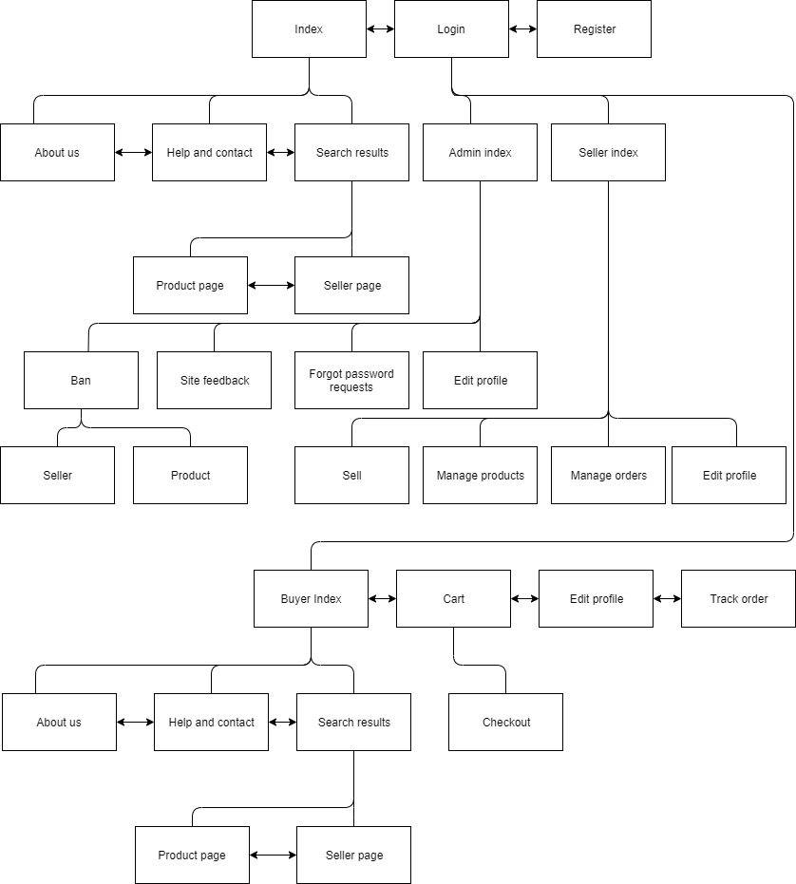

Diagram 20: Navigational structure of built website

When users access to the website, they will be in the index page which is home page of the website. In index, there are two buttons for users to access to login and register. Users can choose to access to the website without login, but if they are willing to perform further facility like buy or sell products they have to login to the system if they have an account or they can register one in order to perform these actions. There are a lot of webpages can be accessed even though the users do not log in such as about us, help and contact, search results. In search results page, if there is seller or product results found the user can also get into seller page and product page. And in the seller page the users can go to the product page of products that the seller selling. In product page, it can also go to the seller page of who selling the product. But most importantly, the users without login click buy or add cart buttons it will pop up the login form which means the users have to login to perform these actions. Logged in index page is appeared according the user role. If the users logged in as buyer account, the interface is almost the same with the one without login but there are few more features that are available such as cart, edit profile and track order and logout. After the buyer added one or more products in their cart, they are allowed to get into the checkout page to make their payment. If the users logged in as seller account, the interface are totally different, the dashboard has only five buttons shown which are sell, manage products, manage orders, edit profile and logout. In sell page, the sellers are allowed to upload their product for selling. In manage products page, they can edit their uploaded products. While in manage orders page, sellers can update the shipping status for buyers who bought their products. Next, if user logged in as admin account, the dashboard is same with seller dashboard but with different buttons which are ban, site feedback, forgot password requests, edit profile and logout. In ban page the admin can choose either product or seller, in this page the admin can ban anything or activate them back to active. For site feedbacks page the admin can preview the message sent by users and reply them via email. For the forgot password requests page, admin can send a link to users who requested for resetting their password to reset their password. And edit profile for all user role are same, they can update their details. Lastly, the logout is used to exit to the index page without logged in facilities.

## 4.4 Database related diagrams

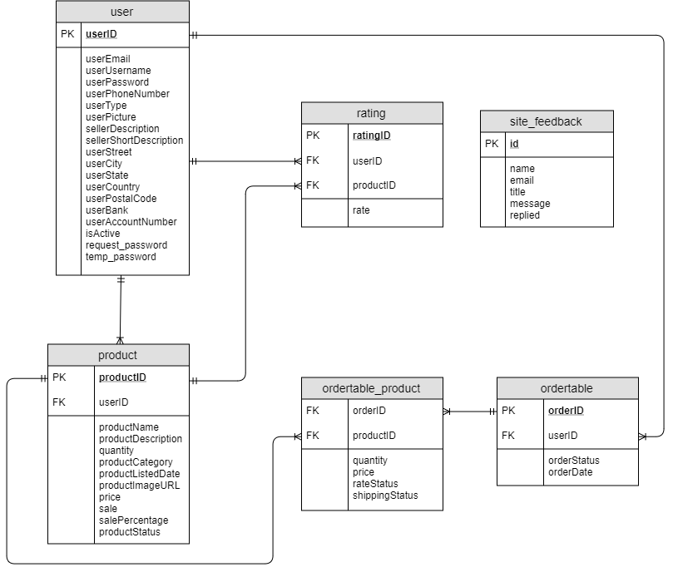

Diagram 22: Entity relations diagram of JKstore website

Since there is login facility in the website, therefore, a table for storing user information is required in database, one seller can sell a lot of products and one buyer can have a lot of orders. And same goes to products and orders, every product selling on website is stored in the database and storing of orders details is to let buyers keep tracking with their purchased products. Many products can be in one order and one product can be in many orders as well. Site feedback is also stored to allow admin preview and respond to the users. Each buyer can rate their purchased products once after it is delivered to the user and one product can be rated by many users.

## 4.5 Site Focus stating objectives to the site using the PHP principles

There are few major focus PHP principles in this web development which are MD5 security, session, login, register and create, read, update and delete (CRUD). MD5 is used to encrypt the password in database using hashing algorithm. It is to protect the password storing in the database from getting steal by someone because of the encrypted password using hashing cannot be revert back to normal form (Security Innovation Europe, 2016). Session is used to store user information when they visiting the website it bring the user information across multiple pages until the user destroy the session by clicking logout or close the web browser (w3schools.com, n.d.). Login and register facilities are used to allow users gain access to some specific webpages according to their user type. With CRUD, some website information with duplicate design can be loaded via reading data from database. Not only this, sellers are also allowed to create their product listing and update their product information via create and update. For administrators, they can ban sellers or products using delete.

## 4.6 Justification of style design choice and targeted audience

The JKstore website is built based on the principles of website design which are simple, consistency, readability, mobile compatibility and navigation. The website has a simple design with most usage of colour of black and white, this make the website looks neat and visitors easier to find their ways, simple is the best (Pawar, 2018). Next, consistency is also consisted in the website, since all the fonts and designs used are almost the same in every webpage and using right styles for the all the elements in the website with CSS (Cascading Style Sheets) it make visitors feel comfort while they are browsing (Pawar, 2018). The website with readability is also the core principle of website design, the website is using fonts and colours for fonts that are easier for users to read. Not only these, mobile compatibility is also implemented in this website, every webpage is responsive and fit in mobile phone screen sizes. Lastly, the website has an easy navigation where users can easily access to other webpages by side navigation bar and top bar menu, and by using of search bar users can easily access for required products or sellers. With these principles of website design, JKstore get to attract its target audience who are the users who like to sell their products or shop online.

# **5.0 Functionalities**

## 5.1 Search

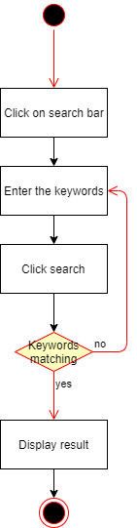

Diagram 5.1.1: Flow chart of search

### **GET value**

if(!isset($_GET['target'])||!isset($_GET['search-key'])){

echo"<script>window.location.href='http://localhost/Assignment/result.php?search-key=&target=';</script>";

}

/* if the user click search without keywords */

if ($_GET['target'] == null){

$sellersearch = $_GET['search-key'];

$productsearch = $_GET['search-key'];

$category = $_GET['search-key'];

$sale="";

/* if the user click see more on seller */

}elseif($_GET['target'] == "seller"){

$sellersearch = $_GET['search-key'];

$productsearch = "no value";

$category = "no value";

$sale="";

/* if the user click see more on sale */

}elseif($_GET['target'] == "sale"){

$sellersearch = "no value";

$productsearch = $_GET['search-key'];

$category = $_GET['search-key'];

$sale = "and sale = '1'";

/* if the user click categories */

}else{

$sellersearch = "no value";

$productsearch = $_GET['search-key'];

$category = $_GET['search-key'];

$sale="";

}

Diagram 5.1.2: Search result based on GET value

Before start searching result from database the search keywords are based on these GET value. As you can see, if the users delete the “?search-key=&target=” in URL it will goes back to the one with GET values which is line 48 to 49. I is to check what values have to assigned to each of the variables. For instance, if the users are searching for seller there is only sellers result will be showed, same goes to others. For else, it is actually for searching products.

$seller_sql = "select * from user where userType = 2 and userUsername like '%".$sellersearch."%' and isActive=2";

$seller_result = mysqli_query($conn,$seller_sql);

Diagram 5.1.3: Displaying sellers result based on target GET value

$product_sql = "select * from product inner join user on product.userID = user.userID where (productCategory like '%".$category."%' or productName like '%".$productsearch."%' or productDescription like '%".$productsearch."%') ".$sale." and productStatus = 1 and user.isActive = 2 order by sale desc";

$product_result = mysqli_query($conn,$product_sql);

Diagram 5.1.4: Displaying products result based on target GET value

The keywords in SQL commands will be changed based on GET values therefore, it will be showed different results based on what users want to search.

## 5.2 Login

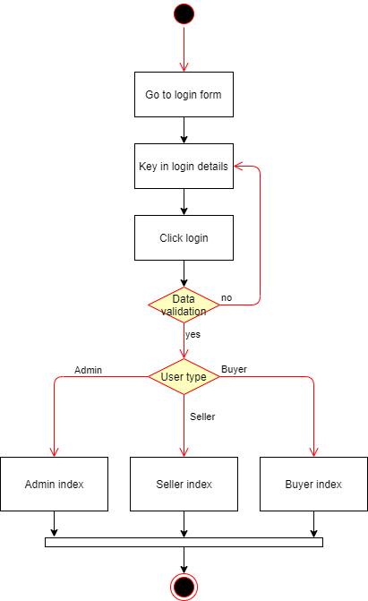

Diagram 5.2.1: Flow chart of login

<?php

// CONNECTION

include("connection.php");

//LOGIN algorithm

if(isset($_POST['loginsubmit'])){

if(!isset($_SESSION['login'])){

$login_email = mysqli_real_escape_string($conn,$_POST['login-email']);

$login_password = mysqli_real_escape_string($conn,$_POST['login-password']);

$login_sql ="select * from user where userEmail = '".$login_email."' and userPassword = '".md5($login_password)."' and (isActive >0);";

$login_result = mysqli_query($conn,$login_sql);

if (mysqli_num_rows($login_result)==1){

$login_rows = mysqli_fetch_array($login_result);

$login=1;

$_SESSION['login'] = $login;

$_SESSION['login_ID'] = $login_rows['userID'];

$_SESSION['login_username'] = $login_rows['userUsername'];

$_SESSION['login_email'] = $login_rows['userEmail'];

$_SESSION['usertype'] = $login_rows['userType'];

echo "<script>window.location.reload(true);</script>";

}

else{

echo "<script type='text/javascript'>showLoginFailed();</script>";

}

}

}

?>

Diagram 5.2.2: Login algorithm

Once the email and password are validated, some necessary data are stored by using session. But if the email and password are not validated, the login failed form will pop up to notify the users they are entering wrong email or password or if the users are sellers their account might be get ban by admin.

<?php

session_start();

if(isset($_SESSION['login'])){

$login = $_SESSION['login'];

$login_id = $_SESSION['login_ID'];

$login_username=$_SESSION['login_username'];

$login_email = $_SESSION['login_email'];

$login_usertype = $_SESSION['usertype'];

if($login_usertype == 2){

echo "<script>window.location.href='seller_page_index.php';</script>";

}elseif($login_usertype == 0){

echo "<script>window.location.href='admin_page_index.php';</script>";

}

}else{

$login=0;

}?>

Diagram 5.2.3: Check login algorithm in every webpage

With the code in Diagram 5.2.3, the users are directed to the specific location based on their user type. For instance, if user type equals to 2 it goes to seller page and if it equals to 0 it goes to admin page, else remain same page.

## 5.3 Add to cart and buy

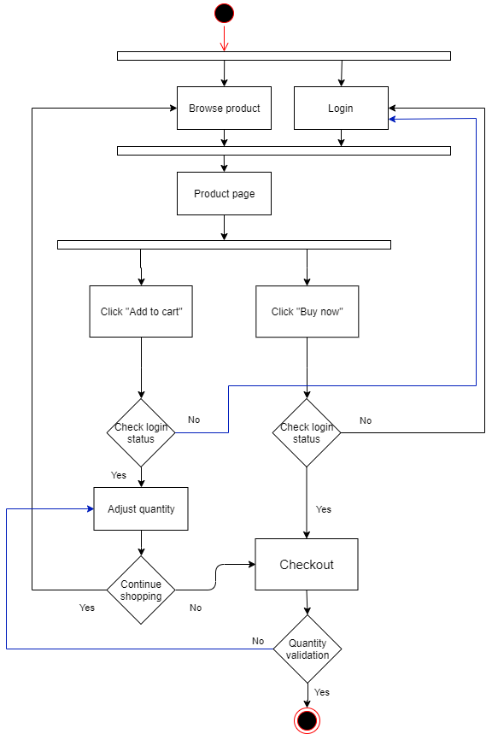

Diagram 5.3.1: Flow chart of add to cart and buy

if(isset($_GET['addcart'])||isset($_GET['buynow'])){

$checkcart_sql="select * from ordertable where orderStatus = 0 and userID=".$login_id;

$checkcart_result = mysqli_query($conn,$checkcart_sql);

$checkcart_rows = mysqli_fetch_array($checkcart_result);

if(mysqli_num_rows($checkcart_result)<=0){

$storecart_sql="insert into ordertable (orderStatus,orderDate,userID) values(0,'".date('y-m-d')."',".$login_id.");";

mysqli_query($conn,$storecart_sql);

$checkcart_result = mysqli_query($conn,$checkcart_sql);

$checkcart_rows = mysqli_fetch_array($checkcart_result);

$firstaddcart_sql = "insert into ordertable_product values(".$checkcart_rows['orderID'].",".$_GET['id'].",1,null,0,0);";

mysqli_query($conn,$firstaddcart_sql);

if(isset($_GET['addcart'])){

echo"<script>window.location.href='product.php?id=".$_GET['id']."';</script>";

}else{

echo"<script>window.location.href='checkout.php';</script>";

}

}else{

$checkcartquantity_sql = "select * from ordertable_product where orderID=".$checkcart_rows['orderID']." and productID = ".$_GET['id'];

$checkcartquantity_result = mysqli_query($conn,$checkcartquantity_sql);

if(mysqli_num_rows($checkcartquantity_result)==1){

$addcart_sql="update ordertable_product set quantity=(select quantity from ordertable where orderID=".$checkcart_rows['orderID']." and productID = ".$_GET['id'].")+1 where orderID=".$checkcart_rows['orderID']." and productID =".$_GET['id'];

mysqli_query($conn,$addcart_sql);

}else{

$addanotherproduct_sql="insert into ordertable_product values(".$checkcart_rows['orderID'].",".$_GET['id'].",1,null,0,0);";

mysqli_query($conn,$addanotherproduct_sql);

}

if(isset($_GET['addcart'])){

echo"<script>window.location.href='product.php?id=".$_GET['id']."';</script>";

}else{

echo"<script>window.location.href='checkout.php';</script>";

}

}

}

Diagram 5.3.2: add cart and buy algorithm

If the “add to cart” or “buy now” buttons being clicked by user, it will check whether users have any unpaid order in database if no it will insert one into database else it will using the existing order to add more products into it. After that, if the button being clicked is “buy now” it will redirect the users to checkout page.

### **Update quantity**

<?php

include("connection.php");

include("check_loginAlgorithm.php");

$getorderid_sql="select * from ordertable where userID = ".$login_id." and orderStatus = 0";

$getorderid_result= mysqli_query($conn,$getorderid_sql);

$getorderid_rows = mysqli_fetch_array($getorderid_result);

$selectcart_sql = "select * from ordertable_product inner join ordertable on ordertable.orderID = ordertable_product.orderID where userID = ".$login_id." and orderStatus = 0 and productID = ".$_POST['id'];

$selectcart_result = mysqli_query($conn,$selectcart_sql);

$selectcart_rows = mysqli_fetch_array($selectcart_result);

echo $_POST['product'.$selectcart_rows['productID']];

echo $selectcart_rows['quantity'];

echo $_POST['id'];

if($selectcart_rows['quantity']!=$_POST['product'.$selectcart_rows['productID']]){

$updatequantity_sql="update ordertable_product set quantity = ".$_POST['product'.$selectcart_rows['productID']]." where productID =". $selectcart_rows['productID']." and orderID = ".$getorderid_rows['orderID'];

mysqli_query($conn,$updatequantity_sql);

echo "<script>window.history.back();</script>";

}?>

Diagram 5.3.3: Update quantity

function quantityupdate(id){

cart_quantity= document.getElementById("quantity"+id).submit();

}

Diagram 5.3.4: Javascript function for submitting form

Once the users, change quantity in cart it will execute the javascript function in Diagram 5.3.4 and it will submit the form to execute php scripting in Diagram 5.3.3. It gets the orderID of the current cart and it gets the quantity for the product. And then update the quantity by SQL command.

### **Make payment**

if(isset($_POST['submit'])){

$checkquantity_sql="select * from product inner join ordertable_product on product.productID=ordertable_product.productID inner join ordertable on ordertable_product.orderID = ordertable.orderID where ordertable.userID = ".$login_id." and ordertable.orderStatus=0 and product.quantity >= ordertable_product.quantity";

$checkquantity_result =mysqli_query($conn,$checkquantity_sql);

$check_order_product_sql="select * from ordertable inner join ordertable_product on ordertable.orderID = ordertable_product.orderID where ordertable.userID = ".$login_id." and ordertable.orderStatus = 0";

$check_order_product_result=mysqli_query($conn,$check_order_product_sql);

/* if cart is empty */

if(mysqli_num_rows($check_order_product_result)<=0){

echo "<script>alert('The cart is empty!');</script>";

echo "<script>window.location.href='http://localhost/Assignment/index.php'</script>";

/* check all items in order whether they are sufficient or not */

}elseif(mysqli_num_rows($checkquantity_result)==mysqli_num_rows($check_order_product_result)){

$deductquantity_sql="update product inner join ordertable_product on product.productID=ordertable_product.productID inner join ordertable on ordertable_product.orderID = ordertable.orderID set product.quantity = product.quantity - ordertable_product.quantity where ordertable.userID = ".$login_id." and ordertable.orderStatus=0";

mysqli_query($conn,$deductquantity_sql);

date_default_timezone_set('asia/kuala_lumpur');

$change_orderstatus_sql = "update ordertable set orderStatus = 1,orderDate = '".date("Y-m-d H:i:s")."' where userID = ".$login_id." and orderStatus = 0";

mysqli_query($conn,$change_orderstatus_sql);

while($check_order_product_rows=mysqli_fetch_array($check_order_product_result)){

$checksale_sql="select sale from product where productID = ".$check_order_product_rows['productID']." and sale = 0";

$checksale_result=mysqli_query($conn,$checksale_sql);

if(mysqli_num_rows($checksale_result)==1){

$cart_quantity_check ="select cast((quantity * (select price from product where productID = ".$check_order_product_rows['productID']."))as decimal(11,2)) as price from ordertable_product where productID= ".$check_order_product_rows['productID']." and orderID = ".$check_order_product_rows['orderID'];

$price_result = mysqli_query($conn,$cart_quantity_check);

$price_rows = mysqli_fetch_array($price_result);

}else{

$cart_quantity_check ="select cast((quantity * (select price*(100-salePercentage)/100 from product where productID = ".$check_order_product_rows['productID'].")) as decimal(10,2)) as price from ordertable_product where productID= ".$check_order_product_rows['productID']." and orderID = ".$check_order_product_rows['orderID'];

$price_result = mysqli_query($conn,$cart_quantity_check);

$price_rows = mysqli_fetch_array($price_result);

}

$insert_price ="update ordertable_product set price=".$price_rows['price']." where productID =".$check_order_product_rows['productID']." and orderID =".$check_order_product_rows['orderID'];

$insert_price_result=mysqli_query($conn,$insert_price);

}

echo "<script>alert('Payment made successfully! Your order is now on processing.');</script>";

echo "<script>window.location.href='http://localhost/Assignment/track_order.php'</script>";

/* if one or more of them are not sufficient */

}else{

echo "<script>alert('Some of your items quantity are not sufficient in stock please check again');</script>";

$updatequantity_sql="update product inner join ordertable_product on product.productID=ordertable_product.productID inner join ordertable on ordertable_product.orderID = ordertable.orderID set ordertable_product.quantity = 1 where ordertable.userID = ".$login_id." and ordertable.orderStatus=0 and product.quantity < ordertable_product.quantity";

$updatequantity_result=mysqli_query($conn,$updatequantity_sql);

echo "<script>window.location.href='http://localhost/Assignment/index.php'</script>";

}

}

Diagram 5.3.5: make order as paid order algorithm

First, it will check whether the cart is empty or not if yes back to home page and tell the users their cart is empty therefore their order can’t be paid. If the cart is not empty, it will check whether all quantity of products in cart whether they are sufficient in database, if it is yes, they can pay for their order. Else the products with insufficient quantity in cart will be reset its quantity to 1.

## 5.4 Submitting Feedback form

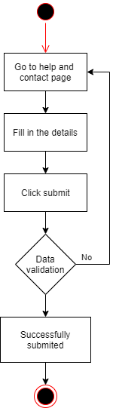

Diagram 5.4.1: Flow chart of submitting feedback form

<?php

include("connection.php");

if(isset($_POST['contactus-submit'])){

$contactus_name = $_POST['contactus-name'];

$contactus_email= $_POST['contactus-email'];

$contactus_title = $_POST['contactus-title'];

$contactus_message = $_POST['contactus-message'];

$feedback_check_sql= "select * from site_feedback where name = '".$contactus_name."' and email = '".$contactus_email."' and title = '".$contactus_title."' and message = '".$contactus_message."'";

$feedback_result=mysqli_query($conn,$feedback_check_sql);

if(mysqli_num_rows($feedback_result)<=0){

$contactus_sql="insert into site_feedback (name, email, title, message, replied) VALUES ('$contactus_name', '$contactus_email', '$contactus_title', '$contactus_message', '0');";

mysqli_query($conn,$contactus_sql);

if (mysqli_affected_rows($conn)>0){

echo "<script>alert('submitted');</script>";

}

}

}

?>

Diagram 5.4.2: Submit help and contact form

After filling up the help and contact form and click submit. It takes all the data from the form and insert them into database by SQL insert command.

## 5.5 Register

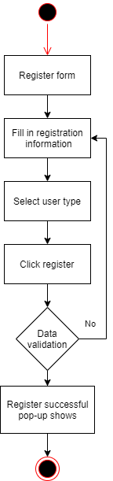

Diagram 5.5.1: Flow chart of register

<?php

include("connection.php");

if(isset($_POST['registersubmit'])){

$register_password = $_POST['register-password'];

$register_retypepassword = $_POST['register-retypepassword'];

if($register_password == $register_retypepassword){

$register_email = $_POST['register-email'];

$checkemail_sql = "select * from user where userEmail ='$register_email'";

$checkemail_result = mysqli_query($conn,$checkemail_sql);

if(mysqli_num_rows($checkemail_result)<=0){

$register_username = $_POST['register-username'];

$register_street =$_POST['register-street'];

$register_city =$_POST['register-city'];

$register_postal = $_POST['register-postal'];

$register_state = $_POST['register-state'];

$register_country = $_POST['register-country'];

$register_phone = $_POST['register-phone'];

$register_usertype = $_POST['usertype'];

$register_sql= "insert into user (userEmail, userUsername, userPassword, userPhoneNumber, userType, userPicture, userStreet, userCity, userState, userCountry, userPostalCode, isActive,request_password) VALUES ('$register_email', '$register_username', '".md5($register_password)."', $register_phone, '$register_usertype', 'jkstore-profile-default.png', '$register_street', '$register_city', '$register_state', '$register_country', $register_postal,1,0);";

mysqli_query($conn,$register_sql);

if(mysqli_affected_rows($conn)<=0){

echo"<script>alert('Register failed')</script>";

}else{

echo"<script type='text/javascript'>showRegisterSuccessful();</script>";

}

}else{

echo"<script>alert('The email has been registered! Try another one.')</script>";

}

}else{

echo"<script>alert('Both passwords are not matched.')</script>";

echo"<script>window.history.back();</script>;";

}

}

?>

Diagram 5.5.2: Register algorithm

In this register algorithm, it will start checking with the password and the retype password see whether they are identical if they are not it will redirect the users back to previous page. If

they are identical, insert into database. If it is inserted successfully the register successful form will be pop up.

## 5.6 Submitting forgot password form

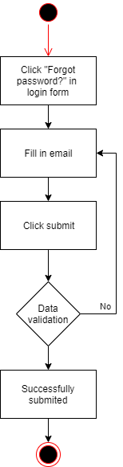

Diagram 5.6.1: Flow chart of submitting forgot password form

<?php

include("connection.php");

if(isset($_POST['forgotsubmit'])){

/* Check whether the email exists or not */

$forgot_email = $_POST['forgot-email'];

$checkemail_sql = "select * from user where userEmail = '".$forgot_email."'";

$checkemail_result = mysqli_query($conn,$checkemail_sql);

if(mysqli_num_rows($checkemail_result)<=0){

echo"<script>alert('The email has not been registered yet!')</script>";

}else{

/* Check whether user request password before or not */

$check_requestpassword_sql= "select * from user where userEmail ='".$forgot_email."' and request_password = 1";

$check_requestpassword_result = mysqli_query($conn,$check_requestpassword_sql);

if(mysqli_num_rows($check_requestpassword_result)<=0){

/* Generate temporary password */

function temp_password(){

$string = "0123456789abcdefghijklmnopqrstuvwxyzABCDEFGHIJKLMNOPQRSTUVWXYZ";

$stringlength=strlen($string);

$temp_password = "";

for ($i = 0; $i <10; $i++){

$temp_password .=$string[rand(0,$stringlength-1)];

}

return $temp_password;

}

$password= temp_password();

$requestpassword_sql="update user set request_password = 1, temp_password = '$password' where userEmail ='".$forgot_email."'";

mysqli_query($conn,$requestpassword_sql);

echo"<script>alert('Requesting for the forgotten password submitted successfully. Kindly wait for the email.')</script>";

}else{

echo"<script>alert('Your request for forgotten password is still on pending')</script>";

}

}

}

?>

Diagram 5.6.2: Submit forgot password algorithm

After users submitting the forgot password form, it will check whether the email filled up by users are existing in database or not if it is not it will tell users that email has not been registered yet, else it will insert the request into database so that admin can see the request in admin site and store a temp password in line 18 to 26 for the link for resetting the password.

## 5.7 Edit profile

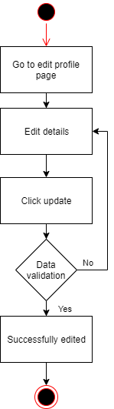

Diagram 5.7.1: Flow chart of edit profile

<?php

if(isset($_POST['updatesubmit'])){

$profile_email = $_POST['profile-email'];

if($profile_email != $login_email){

$checkemail_sql = "select * from user where userEmail like '%".$profile_email."%'";

$checkemail_result = mysqli_query($conn,$checkemail_sql);

if(mysqli_num_rows($checkemail_result)<=0){

$profile_username = $_POST['profile-username'];

$profile_password = $_POST['profile-password'];

$profile_street =$_POST['profile-street'];

$profile_city =$_POST['profile-city'];

$profile_postal = $_POST['profile-postal'];

$profile_state = $_POST['profile-state'];

$profile_country = $_POST['profile-country'];

$profile_phone = $_POST['profile-phone'];

if($_POST['profile-password'] == ""){

$changepassword = "";

}else{

$changepassword = "userPassword = '".md5($profile_password)."',";

}

$editprofile_sql= "update user set userEmail = '$profile_email',userUsername = '$profile_username',".$changepassword." userStreet = '$profile_street', userCity = '$profile_city',userPostalCode = $profile_postal,userState = '$profile_state',userCountry = '$profile_country',userPhoneNumber = '$profile_phone' where userEmail = '$login_email'";

mysqli_query($conn,$editprofile_sql);

if(mysqli_affected_rows($conn)<=0){

echo "<script>alert('Updated failed')</script>";

}else{

$_SESSION['login_email'] = $profile_email;

$_SESSION['login_username'] = $profile_username;

echo "<script>alert('Updated successful')</script>";

}

}else{

echo"<script>alert('The email has been registered! Try another one.')</script>";

}

}else{

$profile_username = $_POST['profile-username'];

$profile_password = $_POST['profile-password'];

$profile_street =$_POST['profile-street'];

$profile_city =$_POST['profile-city'];

$profile_postal = $_POST['profile-postal'];

$profile_state = $_POST['profile-state'];

$profile_country = $_POST['profile-country'];

$profile_phone = $_POST['profile-phone'];

if($_POST['profile-password'] == ""){

$changepassword = "";

}else{

$changepassword = "userPassword = '".md5($profile_password)."',";

}

$editprofile_sql= "update user set userUsername = '$profile_username',".$changepassword." userStreet = '$profile_street', userCity = '$profile_city',userPostalCode = $profile_postal,userState = '$profile_state',userCountry = '$profile_country',userPhoneNumber = '$profile_phone' where userEmail = '$profile_email'";

mysqli_query($conn,$editprofile_sql);

if(mysqli_affected_rows($conn)<=0){

echo "<script>alert('Updated failed')</script>";

}else{

$_SESSION['login_username'] = $profile_username;

echo "<script>alert('Updated successful')</script>";

}

}

}

?>

Diagram 5.7.2: Edit profile algorithm

First, it will check whether users have changed their email or not. It checks the email whether is existed in database, if it is existed then asks the users change to another email else proceed. Next, checking with the password if the input box for password are not filled it won’t update password in database else it updates a new one to database. Same goes to the without changing their email, just that its wont update email in database.

## 5.8 Track order

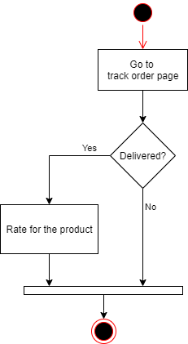

Diagram 5.8.1: Flow chart of track order

$select_order_sql = "select * from ordertable where userID = $login_id and orderstatus = 1 order by orderDate desc";

$select_order_result = mysqli_query($conn,$select_order_sql);

while($select_order_rows = mysqli_fetch_array($select_order_result)){

$select_product_sql = "select ordertable_product.orderID,ordertable.orderDate,ordertable_product.quantity,ordertable_product.price,ordertable_product.shippingStatus,ordertable_product.rateStatus,product.productID,product.productName,product.productImageURL from ordertable inner join ordertable_product on ordertable.orderID = ordertable_product.orderID inner join product on ordertable_product.productID = product.productID where ordertable.orderID = ".$select_order_rows['orderID']." and orderStatus = 1";

$select_product_result = mysqli_query($conn,$select_product_sql);

Diagram 5.8.2: Select for paid orders

The SQL select statement above is to select all the paid orders for buyer in track order page.

### **Rating**

<?php

include("connection.php");

include("check_loginAlgorithm.php");

$insertrate_sql = "insert into rating (rate, userID, productID) values(".$_GET['rate'].",".$login_id.",".$_GET['id'].")";

mysqli_query($conn,$insertrate_sql);

$update_ratestatus_sql="update ordertable_product set rateStatus = 1 where orderID = ".$_GET['orderid']." and productID = ".$_GET['id'];

mysqli_query($conn,$update_ratestatus_sql);

echo "<script>window.history.back();</script>";

?>

Diagram 44: Rate algorithm

Once the users click on the rating stars in track order page, it will insert the rate into database based on the product id.

## 5.9 Seller upload product for selling

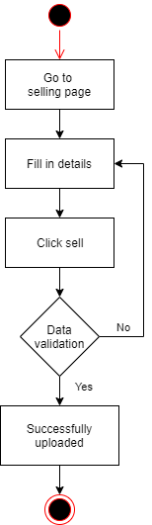

Diagram 5.9.1: Flow chart of selling

if(isset($_POST['sell-product'])){

$product_name = $_POST['product-name'];

$checkname_sql = "select * from product where productName ='$product_name'";

$checkname_result = mysqli_query($conn,$checkname_sql);

if(mysqli_num_rows($checkname_result)<=0){

$product_description = $_POST['product-description'];

$product_category = $_POST['product-category'];

$product_price = $_POST['product-price'];

$product_quantity = $_POST['product-quantity'];

$insertproduct_sql = "insert into product (productName, productDescription, productCategory, price, quantity, productListedDate,userID) values('$product_name','$product_description','$product_category',$product_price,$product_quantity,'".date("Y-m-d")."',$login_id)";

mysqli_query($conn,$insertproduct_sql);

if (mysqli_affected_rows($conn)==1){

$getproductid_sql = "select * from product where userID = $login_id order by productID desc limit 1";

$getproductid_result=mysqli_query($conn,$getproductid_sql);

$getproductid_rows = mysqli_fetch_array($getproductid_result);

**Continue with image upload**

Diagram 47: Insert product information

Before inserting the product details, it will check with the product name whether it is existed in the database, if it is not existed the product information will be inserted into database and the product will be now on list.

### **Image uploading**

if(isset($_FILES['product-image'])){

if($_FILES['product-image']['error']>0){

}else{

$allowed = array('image/jpeg','image/jpg','image/png');

if (in_array($_FILES['product-image']['type'], $allowed)){

$filename = $_FILES['product-image']['name'];

$filename_split = explode(".", $filename);

$extension = end($filename_split);

$tmp = $_FILES['product-image']['tmp_name'];

$dir = "images/product box/".$getproductid_rows['productID'].".".$extension;

if (move_uploaded_file($tmp, $dir)) {

$update_picture_sql="update product set productImageURL = '".$getproductid_rows['productID'].".".$extension."' where productID = ".$getproductid_rows['productID'];

mysqli_query($conn,$update_picture_sql);

echo "<script>alert('Successfully listed. The product has now on list.');</script>";

echo "<script>window.location.href= 'seller_page_index.php';</script>";

}

}

}

}

Diagram 48: Image uploading

First, if the input type of file has chosen an image, the code in Diagram 48 will be executed. After that, it will check whether there are errors, if no it checks with the image file type whether it is .jpeg, .jpg or .png file type. If it is one of the file types mentioned it will store the image into the temp file and move it to the specified file location afterward and rename it as its product id in database. Lastly, store the image name in the database.

## 5.10 Seller manage product

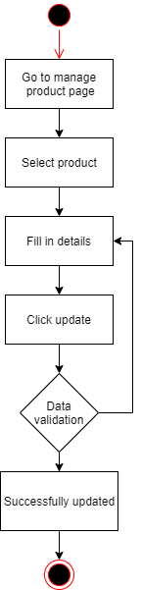

Diagram 5.10.1: Flow chart of manage product

The coding for updating product information is totally same with uploading product but instead of using insert command it uses update command in SQL statement.

## 5.11 Manage order

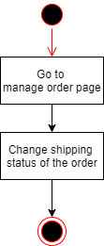

Diagram 5.11.1: Flow chart of managing order

<?php

include("connection.php");

$orderid = $_POST['orderid'];

$productid = $_POST['productid'];

$shippingstatus = $_POST['shipping-status'];

$update_shippingstatus_sql = "update ordertable_product set shippingStatus = $shippingstatus where orderID = $orderid and productID = $productid";

mysqli_query($conn,$update_shippingstatus_sql);

if(mysqli_affected_rows($conn)>0){

echo "<script>alert('Shipping status has been updated successfully.');</script>";

echo "<script>window.location.href='http://localhost/Assignment/seller_page_manage_order.php';</script>";

}else{

echo "<script>alert('Shipping status has failed to update.');</script>";

}

?>

Diagram 5.11.2: Update shipping status

The way of updating shipping status is same as the update quantity in cart. First there will be a dropdown for sellers to change to shipping status. It uses update statement to change the shipping status.

## 5.12 Admin ban sellers or products

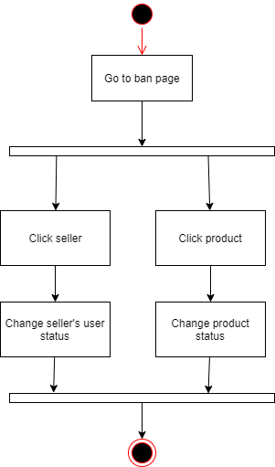

Diagram 5.12.1: Flow chart of banning

<tr>

<td align="center">

<form method="GET">

<input class="profile-button" style="width:120px;" type="submit" name="sellers" value="Sellers"/>

</form>

</td>

</tr>

<tr>

<td align="center">

<form method="GET">

<input class="profile-button" style="width:120px;" type="submit" name="products" value="Products"/>

</form>

</td>

</tr>

<?php }elseif (isset($_GET['sellers'])){ ?>

**Seller listing here**

<?php }elseif (isset($_GET['products'])){ ?>

**Product listing here**

<?php } ?>

Diagram 5.12.2: Selection for ban

When the admin gets into the ban page there are two buttons which are seller and product. If admin choose seller it will shows sellers list same goes to product.

<?php

/* if admin change seller status */

if(isset($_POST['user-status'])){

$userid=$_POST['userid'];

$userstatus = $_POST['user-status'];

$update_userstatus_sql="update user set isActive = $userstatus where userID = $userid";

mysqli_query($conn,$update_userstatus_sql);

}

/* if admin change product status */

if(isset($_POST['product-status'])){

$productid=$_POST['productid'];

$productstatus = $_POST['product-status'];

$update_productstatus_sql="update product set productStatus = $productstatus where productID = $productid";

mysqli_query($conn,$update_productstatus_sql);

}

?>

Diagram 5.12.3: Change seller account status or product status

These codes are to update the status of seller account and product when the dropdown selection being changed.

## 5.13 Admin preview and reply site feedbacks from users

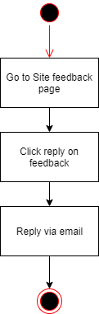

Diagram 5.13.1: Flow chart of previewing site feedback

<?php

$getfeedback_sql="select * from site_feedback";

$getfeedback_result = mysqli_query($conn,$getfeedback_sql);

?>

Diagram 5.13.2: Display site feedback from users

With the code in Diagram 5.13.2, it returns all the messages sent by users to be displayed in admin site feedback page by using select statement of SQL command.

<?php

include("connection.php");

if(isset($_GET['id'])){

$getfeedback_sql="select * from site_feedback where id=".$_GET['id'];

$getfeedback_result = mysqli_query($conn,$getfeedback_sql);

$getfeedback_rows = mysqli_fetch_array($getfeedback_result);

/* Update site feedback to replied */

$updatereplied_sql = "update site_feedback set replied = 1 where id =".$_GET['id'];

mysqli_query($conn,$updatereplied_sql);

echo "<script>window.location.href='http://localhost/Assignment/admin_page_sitefeedbacks.php?id=".$_GET['id']."';</script>";

}?>

Diagram 5.13.3: Update reply status

After clicking reply, the reply status for the message will be update to 1. And redirect back to admin site feedback page.

<?php

if(isset($_GET['id'])){

$feedback_sql="select * from site_feedback where id=".$_GET['id'];

$feedback_result = mysqli_query($conn,$feedback_sql);

$feedback_rows = mysqli_fetch_array($feedback_result);

echo "<script>window.location.href='mailto:".$feedback_rows['email']."?Subject=JKstore | RE: ".$feedback_rows['title']."&Body=Dear ".$feedback_rows['name'].",%0D%0A%0D%0A".$login_username."%0D%0AAdministrator, JKstore';</script>";

}

?>

Diagram 5.13.4: Email to user

After redirect back to admin site feedback page, the email client will be showed up with filled title and greeting and now the admin just has to type in the message and reply to the user.

## 5.14 Admin send link for resetting password

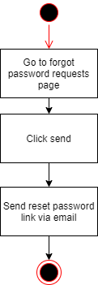

Diagram 5.14.1: Flow chart of sending reset password link

<?php

$getemail_sql="select * from user where request_password = 1";

$getemail_result = mysqli_query($conn,$getemail_sql);

?>

Diagram 5.14.2: Display all the resetting password requests from users

It returns all the requests sent by users to be displayed in admin forgot password page by using select statement of SQL command.

<?php $emailid=$getemail_rows['userID']."%26temp=".$getemail_rows['temp_password']; ?>

<a href="mailto:<?php echo $getemail_rows['userEmail'];?>?Subject=JKstore | Reset Your Password&body=RESET password: <?php echo "http://localhost/Assignment/common/algorithms/resetpassword.php?id=".$emailid;?>" class="profile-button">Send</a>

Diagram 5.14.3: Link to email the reset password link

After the admin click send, it will show up the email client with title of “Reset your password” and link for users to reset their password. The reset password link contains the user id and the temp password, the password generates after users request for reset password.

## 5.15 Resetting password

<?php

include("connection.php");

if(isset($_GET['id'])&&isset($_GET['temp'])){

$userid = $_GET['id'];

$temp_password = $_GET['temp'];

$resetpassword_sql="update user set userPassword = '".md5(12345678)."', request_password = 0, temp_password='' where userID= $userid and temp_password = '".$temp_password."'";

$resetpassword_result = mysqli_query($conn,$resetpassword_sql);

if(mysqli_affected_rows($conn)>0){

echo "<script>alert('Password reset successfully. Your password has now been reset to 12345678.');</script>";

echo "<script>window.location.href='http://localhost/Assignment/index.php';</script>";

}else{

echo "<script>alert('Password reset failed.');</script>";

echo "<script>window.location.href='http://localhost/Assignment/index.php';</script>";

}

}else{

echo "<script>window.location.href='http://localhost/Assignment/index.php';</script>";

}

?>

Diagram 57: Reset password

After the users click on the resetting password link sent by admin, if the user id and temp password are matched in database the users’ password will be reset to ‘12345678’ with MD5 encrypted.

## 5.16 Database connectivity

In this section, it talks about how PHP scripting connects to the database.

<?php

$server = 'localhost';

$username = 'root';

$password = '';

$db = 'jkstore';

$conn = mysqli_connect($server,$username,$password,$db);

if(mysqli_connect_error()){

die('Connection error');

}

?>

Diagram 45: Connection.php

The scripting used above is to connect to a server called ‘localhost’ and ‘jkstore’, database used in MySQL by using mysqli_connect() with its username and password used for the server.

## 5.17 Logout

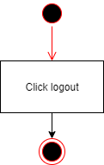

Diagram 5.17.1: Flow chart of logout

<?php

session_start();

if(session_destroy()) {

header("Location: http://localhost/Assignment/index.php");

}

?>

Diagram 5.17.2: Logout algorithm

When the users pressed the logout, the code shown above will be executed. It destroys the session all the data stored in session will be removed and redirect users to homepage.

## 5.18 MD5 security

$register_sql= "insert into user (userEmail, userUsername, userPassword, userPhoneNumber, userType, userPicture, userStreet, userCity, userState, userCountry, userPostalCode, isActive,request_password) VALUES ('$register_email', '$register_username', '".**md5($register_password)**."', $register_phone, '$register_usertype', 'jkstore-profile-default.png', '$register_street', '$register_city', '$register_state', '$register_country', $register_postal,1,0);";

Diagram 5.18.1: md5() used in register

$login_sql ="select * from user where userEmail = '".$login_email."' and userPassword = '".**md5($login_password)**."' and (isActive >0);";

Diagram 5.18.2: md5() used in login

The MD5 security used in login and register is to encrypt the password of users just in case if someone break into system but they can’t directly get the passwords, even the admin also can get the password of users which make the system more secure. According to (Security Innovation Europe, 2016), the encrypted password can’t be decrypted using MD5().

## 5.19 Forms pop-up

function showLogin(){

login.style.display ="table";

}

function hideLogin(){

login.style.display ="";

}

Diagram 5.19.1: Functions of changing style display

These scripting are to change the style display of forms to make them show up like pop-up.

# **6.0 Main section (User guidance & sample screen)**

Registered account

|  |  |  |
| --- | --- | --- |
| Email | password | User type |
| [jinqkuenlim@outlook.com](mailto:jinqkuenlim@outlook.com) | 12345678 | Admin |
| [jinqkuenl@gmail.com](mailto:jinqkuenl@gmail.com) | 12345678 | Buyer |
| nvidia@hotmail.com | 12345678 | Seller |

## 6.1 Home page (not yet logged in)

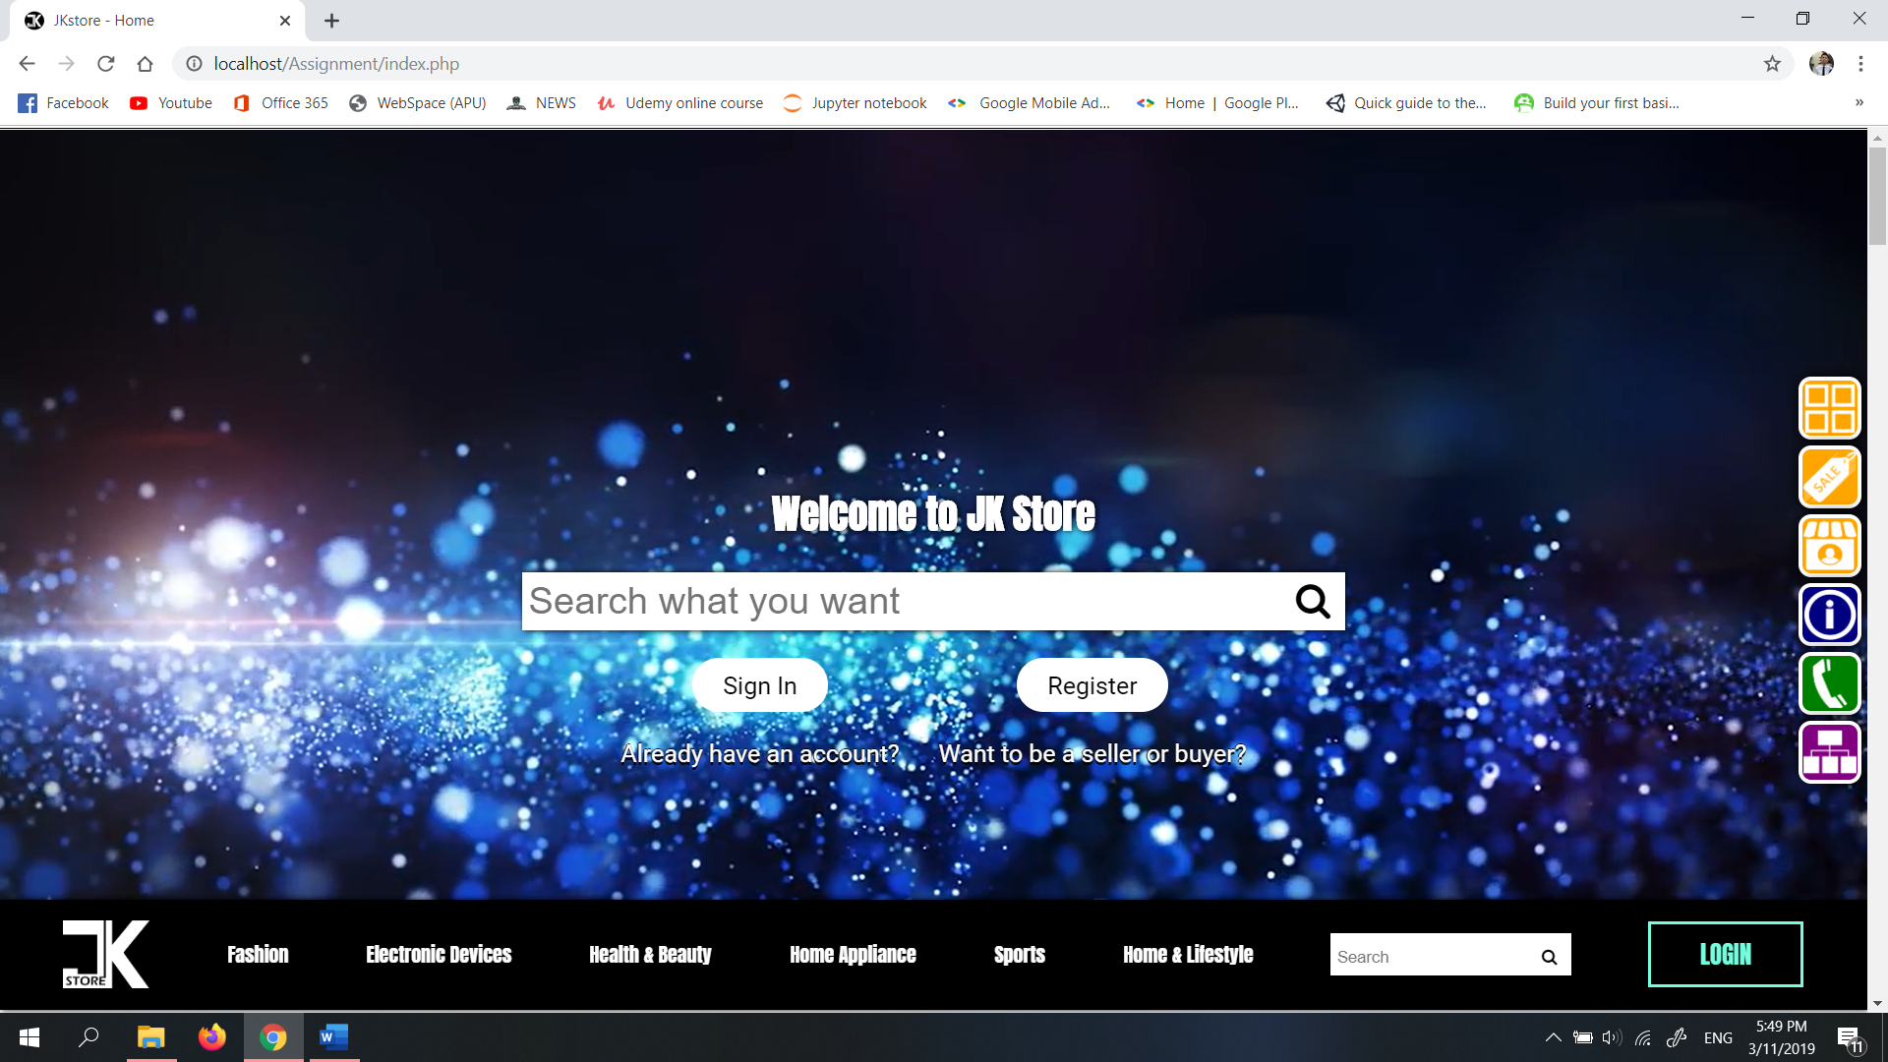

Diagram 6.1: Home page (without login)

In home page, users can login, register and search for something. If the users click login the login form will shows up.

## 6.2 Login form (pop-up)

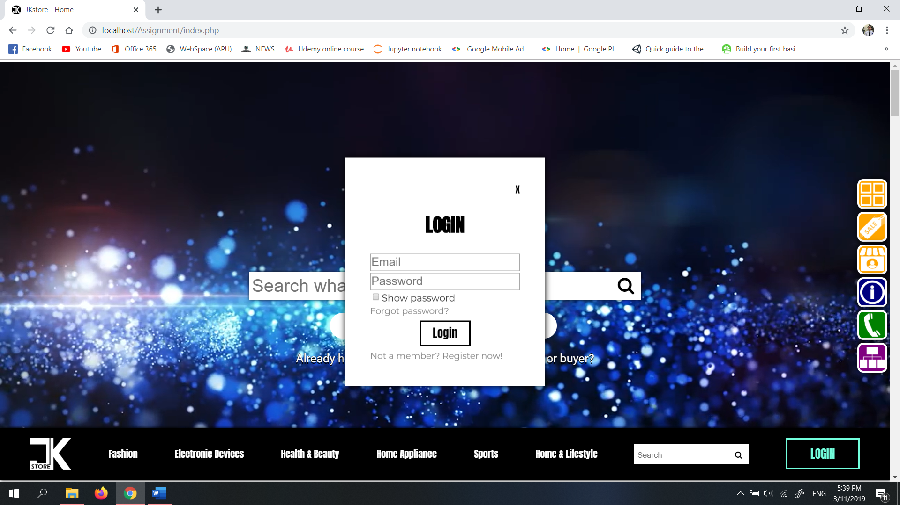

Diagram 6.2: Login form (pop-up)

In order to login, the users have to fill up their registered email and password and then press login. Different user type will go to different page such as seller go to seller homepage in 6.16 and admin go to admin homepage in 6.20. If the users haven’t register yet they can click “Not a member? Register now!” link to go to the register form or if they forgot their password they can click on “Forgot password?” to request for resetting password.

## 6.3 Register form (pop-up)

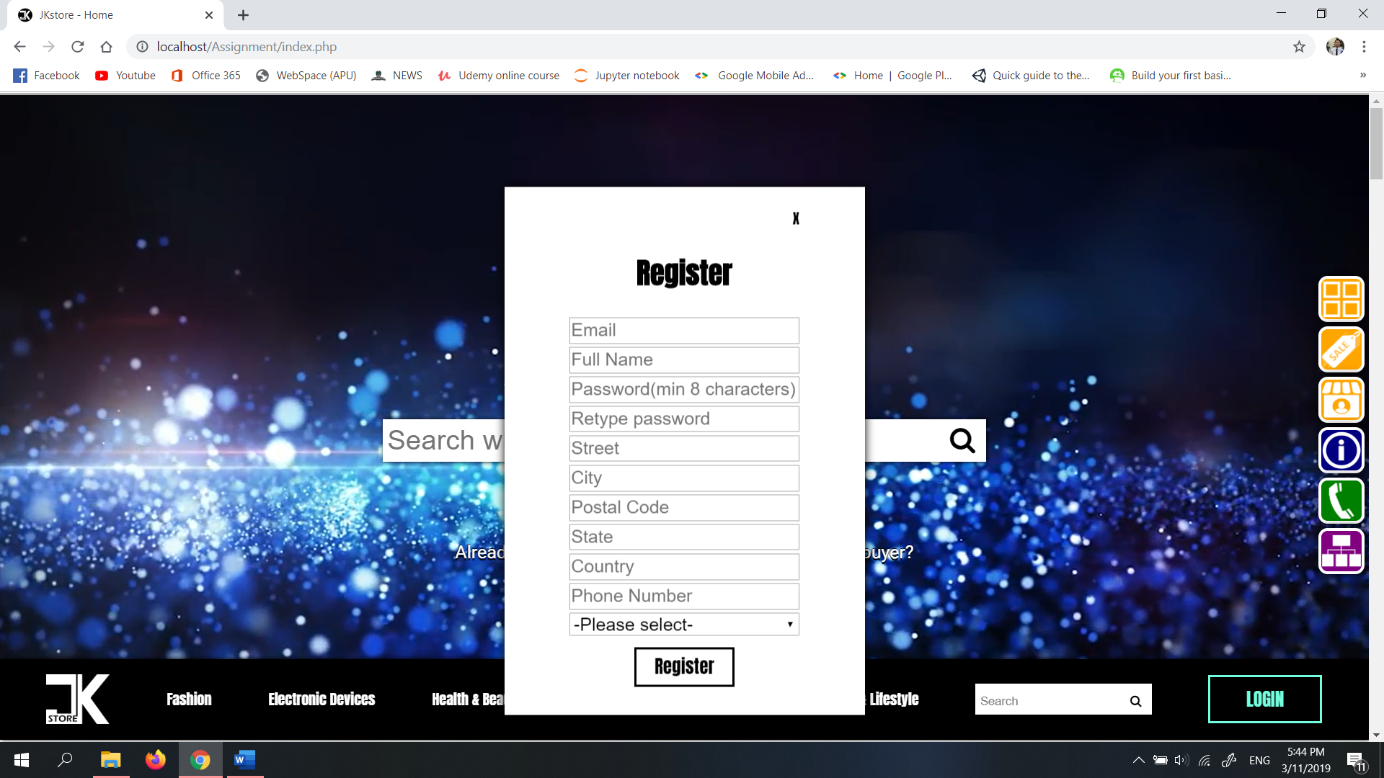

Diagram 6.3: Register form (pop-up)

In this register form, users have to fill up all required information and choose to register as buyer or seller. After registration, the login form will be showed.

## 6.4 Forgot password form (pop-up)

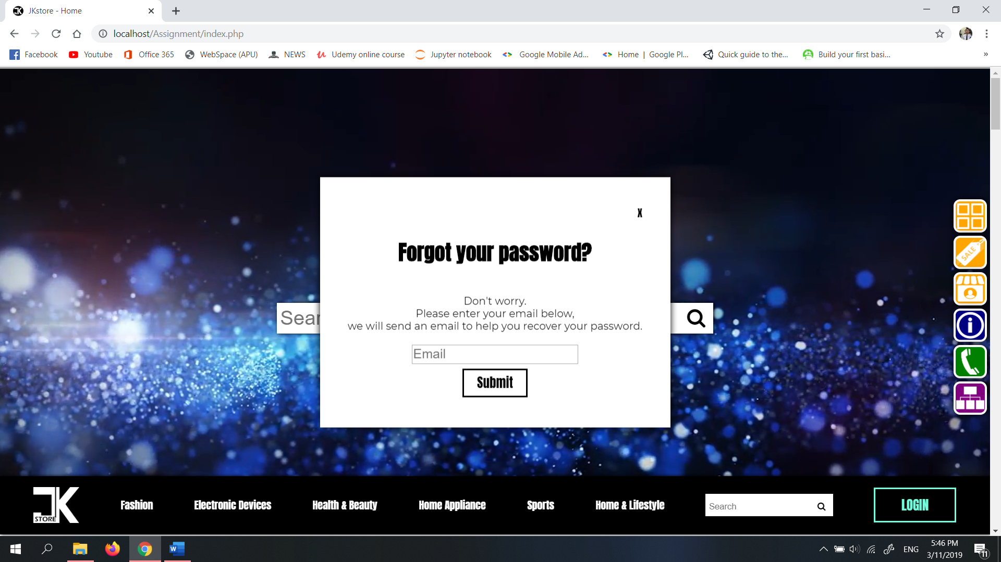

Diagram 6.4: Forgot password form (pop-up)

This form will be showed after users click “Forgot password?” in login form. This form is to let users enter their email for requesting reset password.

## 6.5 Side navigation bar



7

6

5

43

2

3

1

Diagram 6.5: Side navigation bar

|  |  |  |
| --- | --- | --- |
|  | Functionalities (homepage only) | Functionalities |
| 1 | Cart pop-up shows | Cart pop-up shows |
| 2 | Scroll to categories part | Go to search result page with product results |
| 3 | Scroll to sale part | Go to search result page with sale product results |
| 4 | Scroll to seller part | Go to search result page with seller results |
| 5 | Scroll to about us part | Go to about us page |
| 6 | Scroll to help and contact part | Go to help and contact page |
| 7 | Scroll to footer/sitemap | Scroll to footer/sitemap |

## 6.6 Home page (buyer logged in)

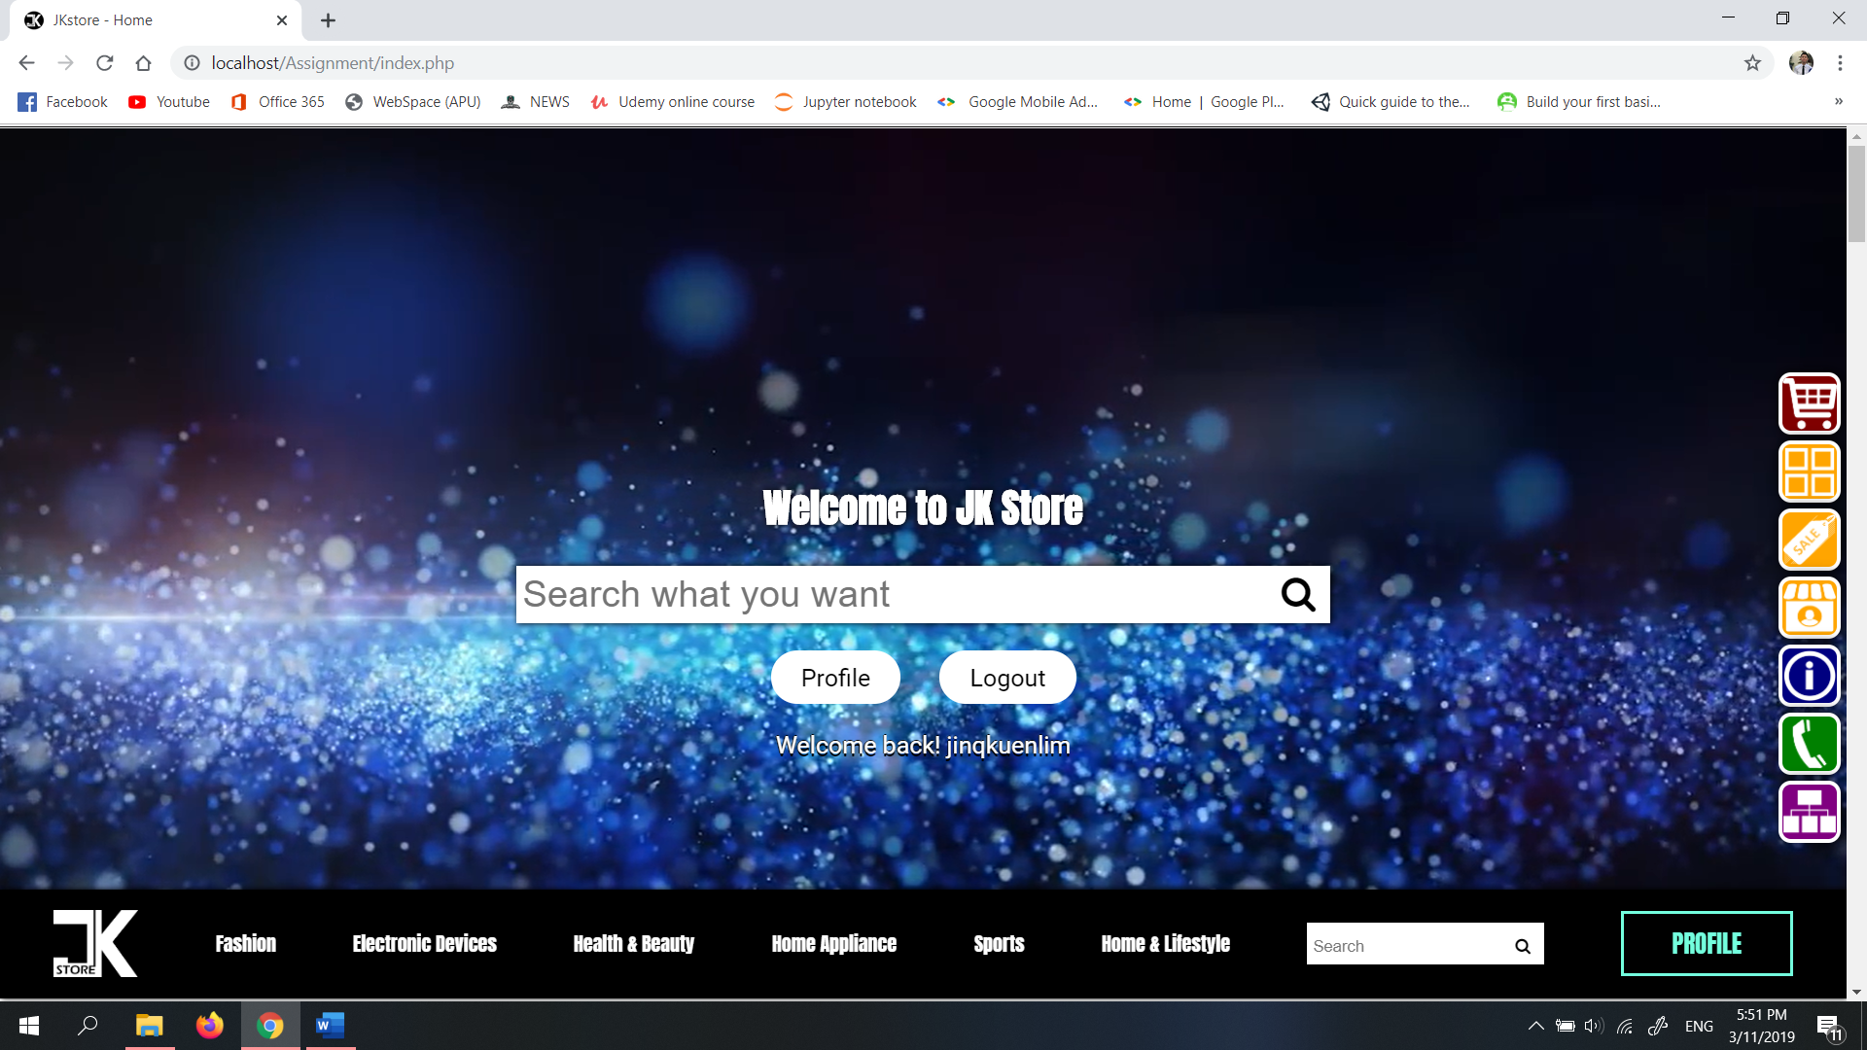

Diagram 6.6: Home page (with buyer logged in)

## 6.7 Search result page

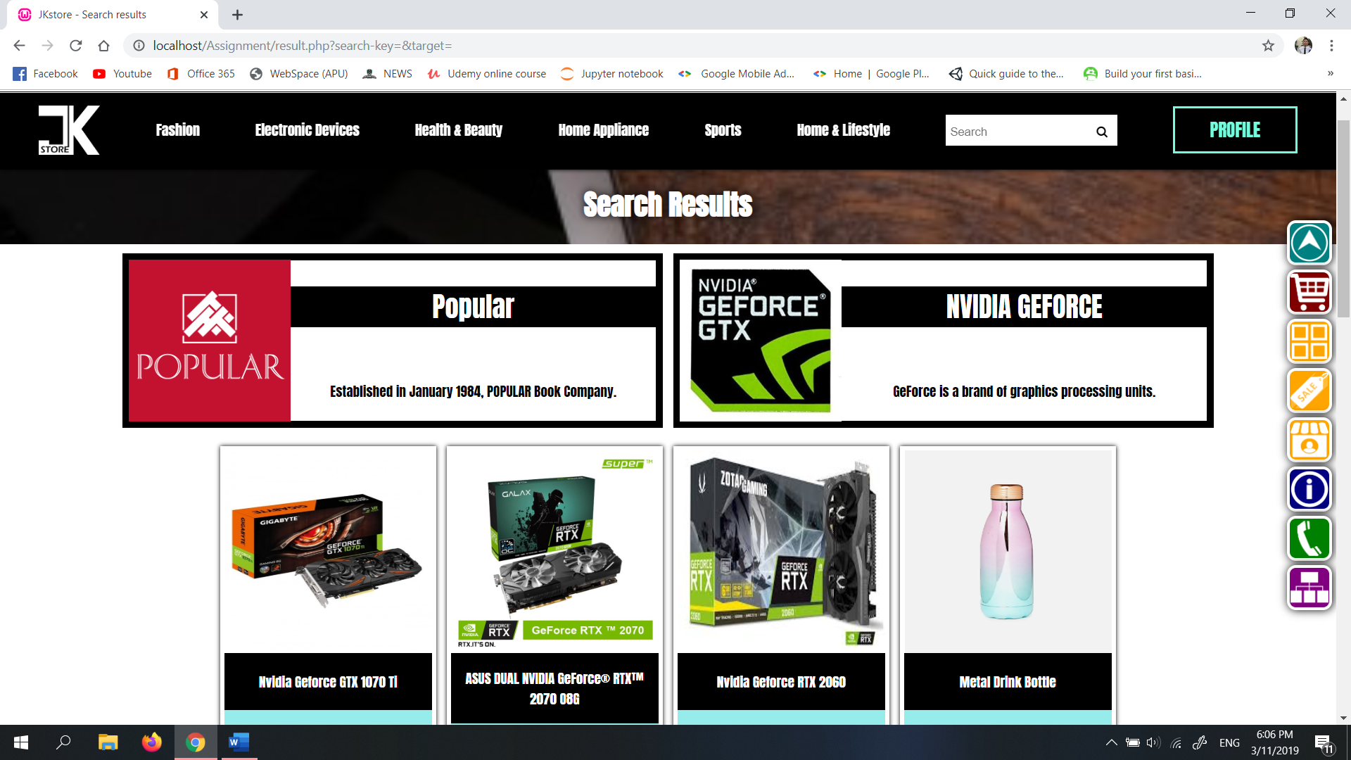

Diagram 6.7: Search result page

After searching, the page shown in Diagram 6.7 shows. This is page that shows all the results based on the search keywords by users or the categories.

## 6.8 Seller page

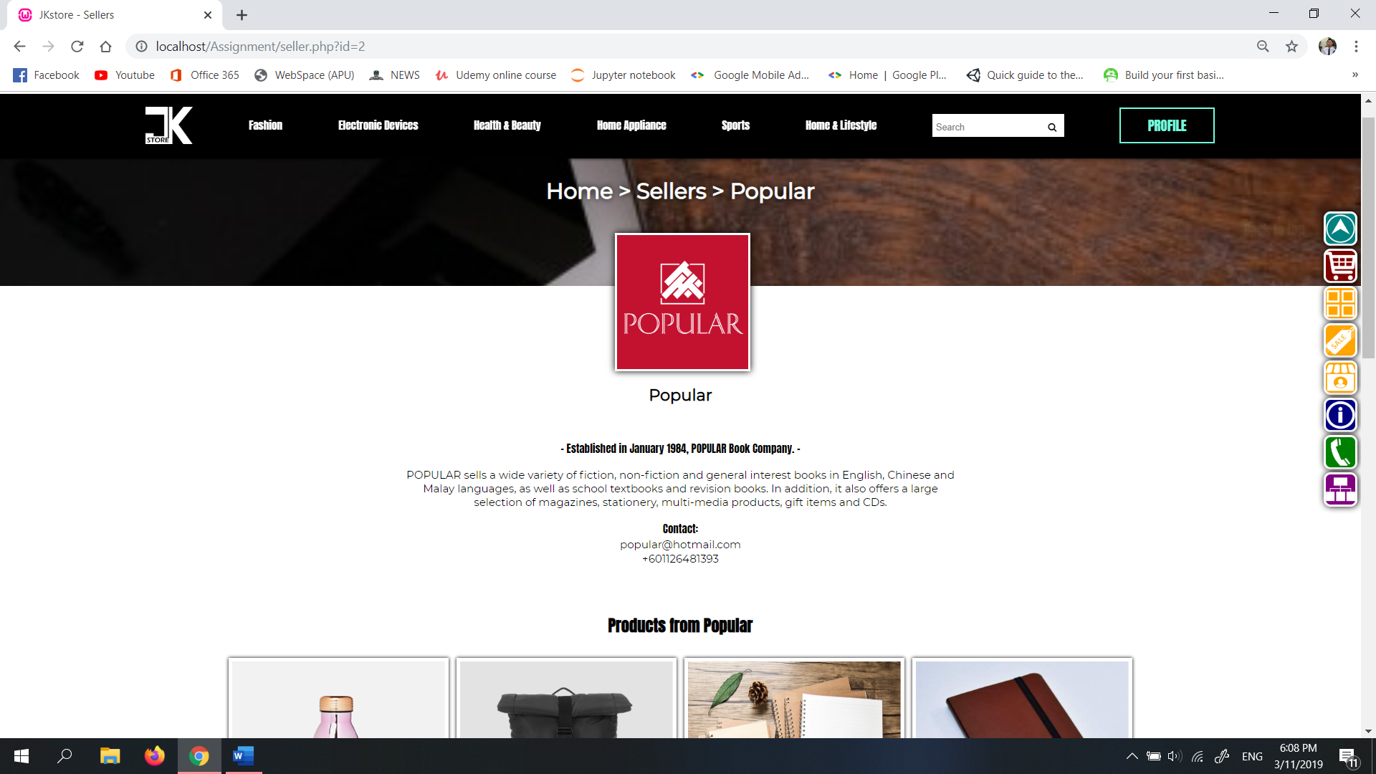

Diagram 6.8: Seller page

The page that shows the information of seller and its selling products.

## 6.9 Product page

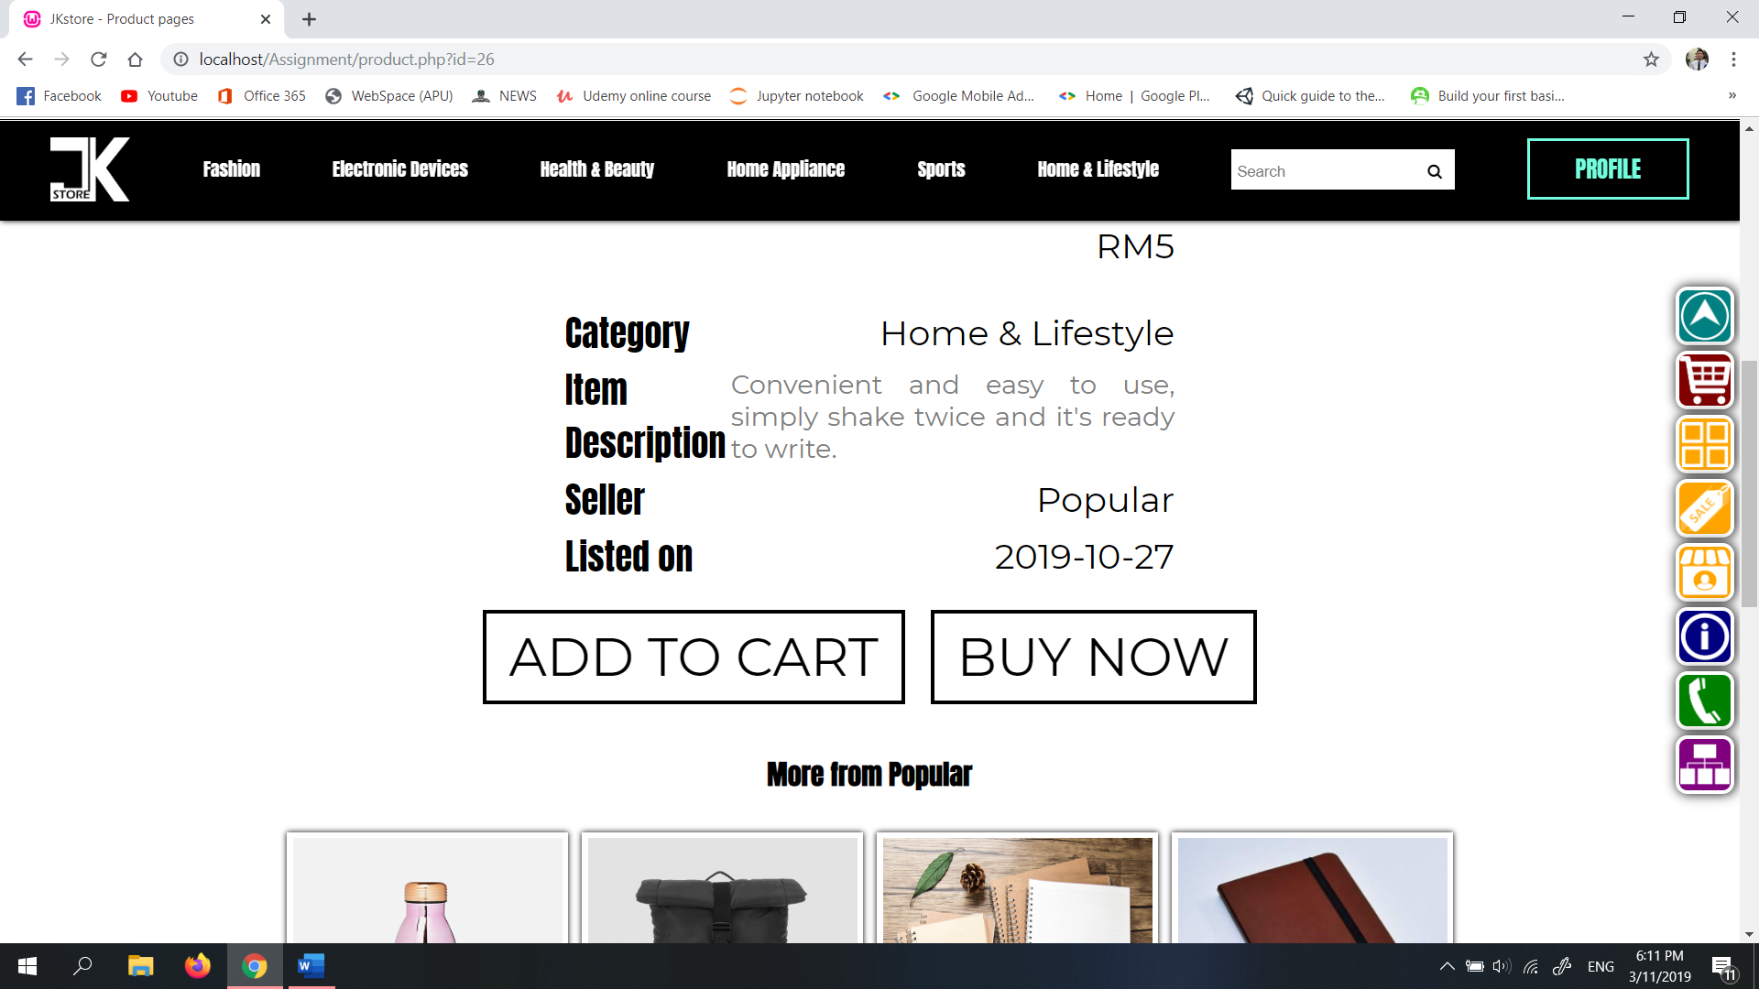

Diagram 6.9: Product page

This page displays the information of one product and if users want to purchase the product they can simply click ‘add to cart’ or ‘buy now’.

## 6.10 Shopping cart pop-up (buyer)

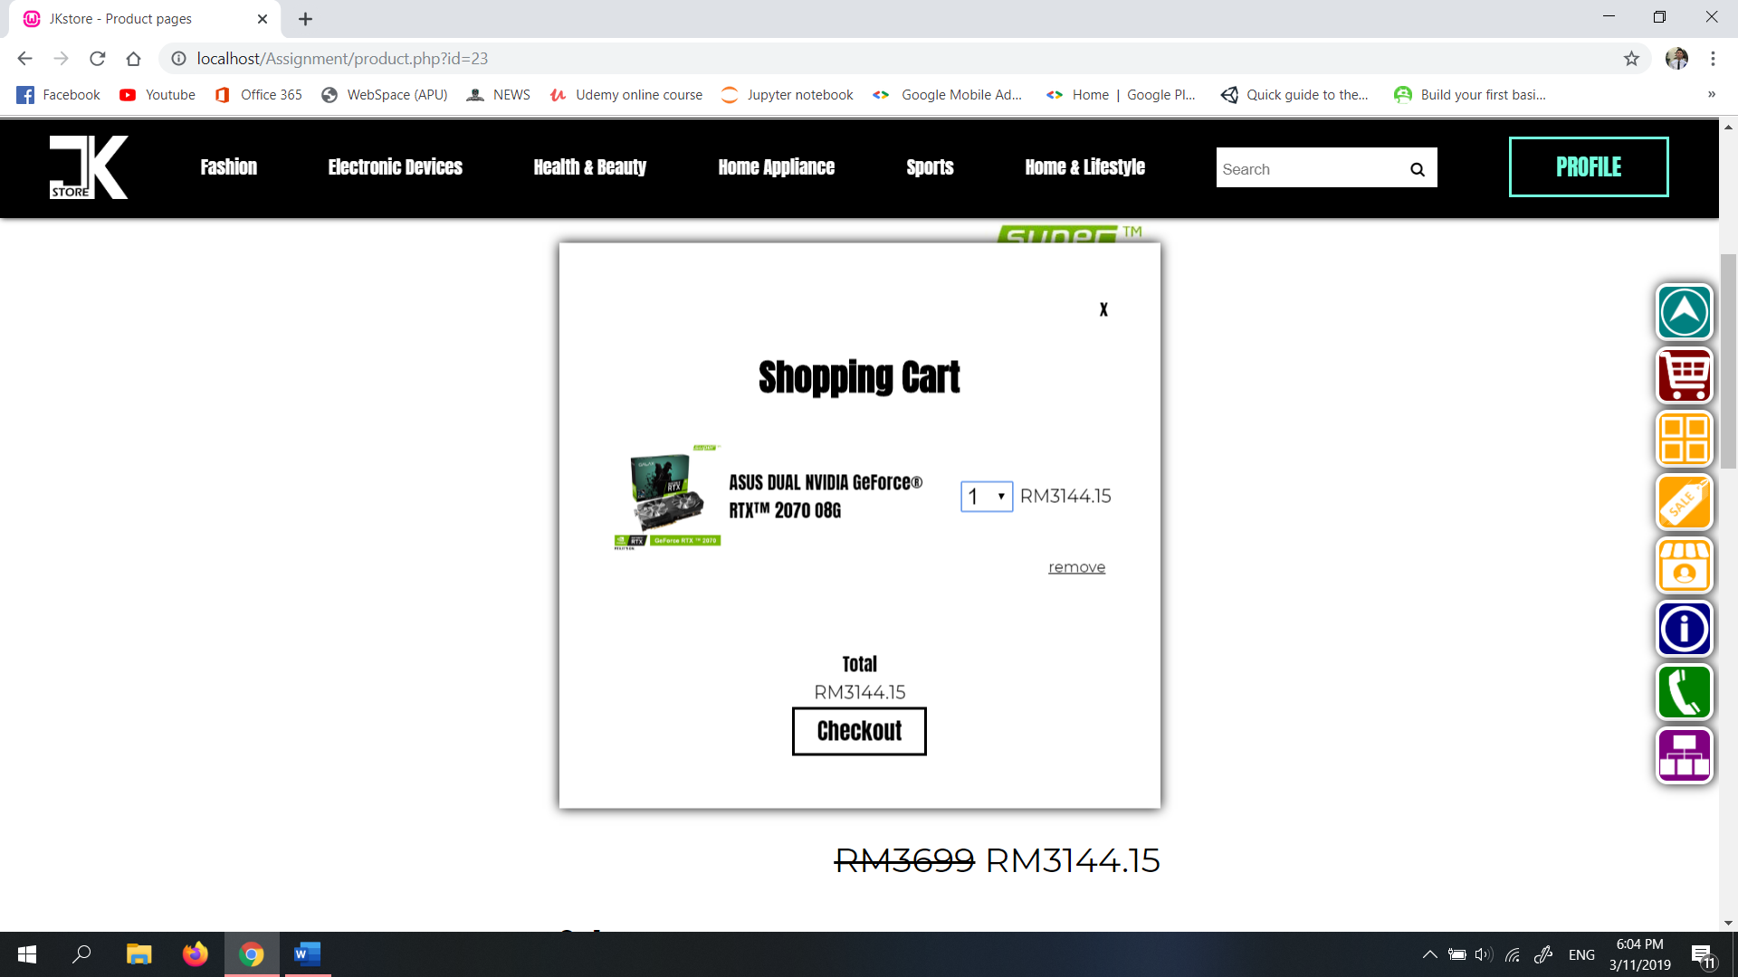

Diagram 62: Shopping cart (pop-up)

Click ‘checkout’ to proceed to checkout page.

## 6.11 Checkout page (buyer)

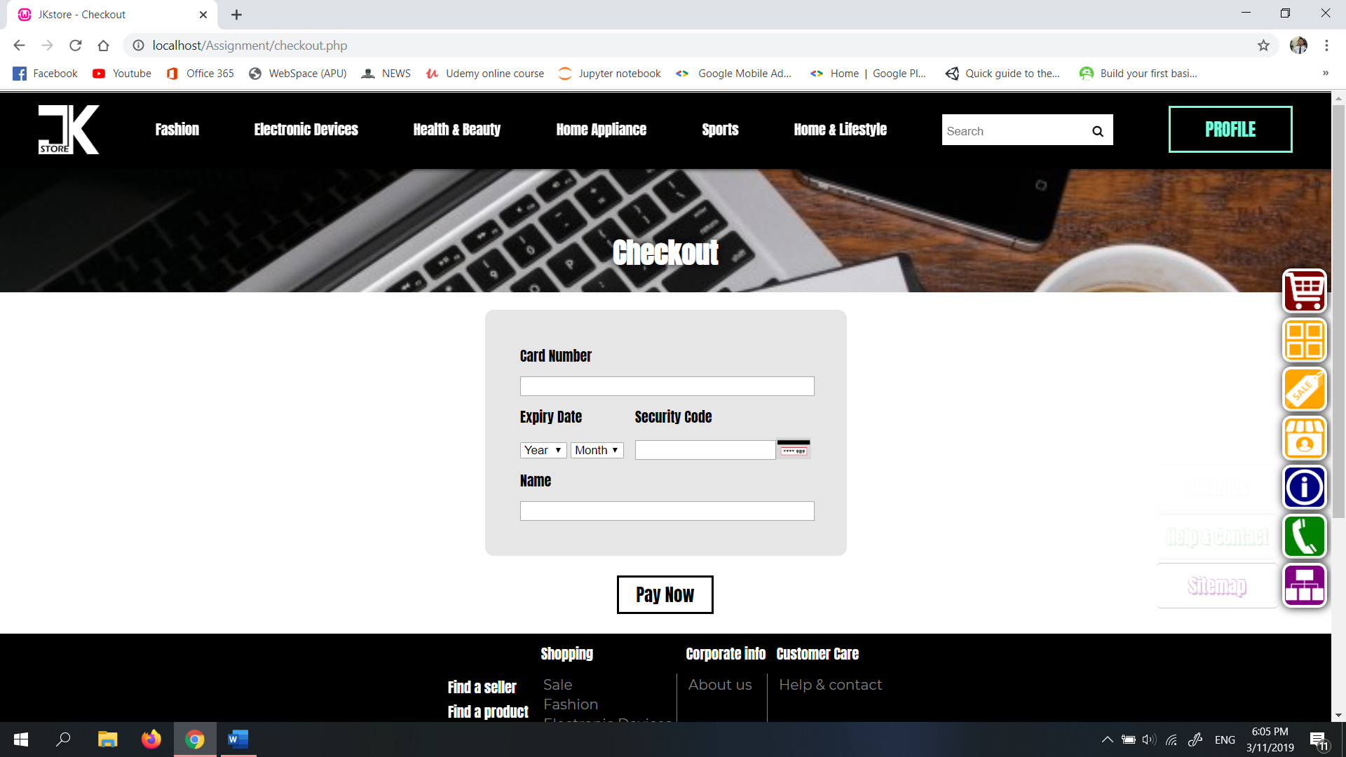

Diagram 6.11: Checkout page

In this page, buyers get to purchase their products in cart by filling up details and click ‘Pay now’.

## 6.12 Edit profile (buyer, seller, admin)

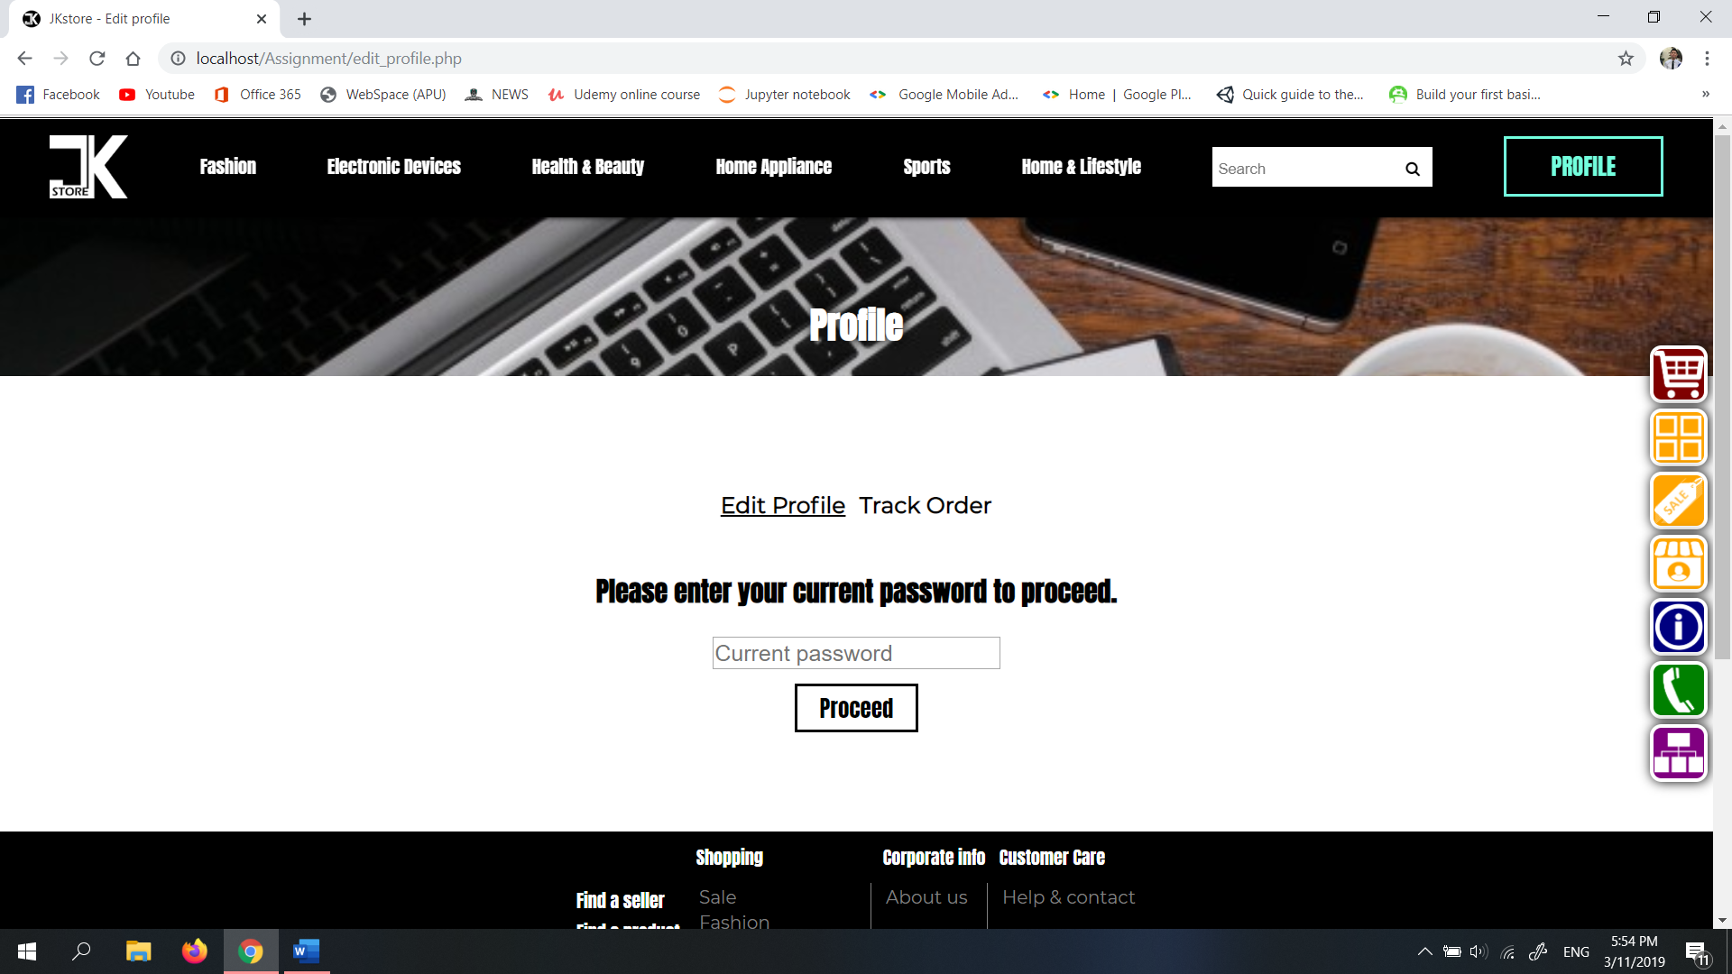

Diagram 6.12.1: Edit profile (1)

In this page users have to enter their password correctly before start editing their details.

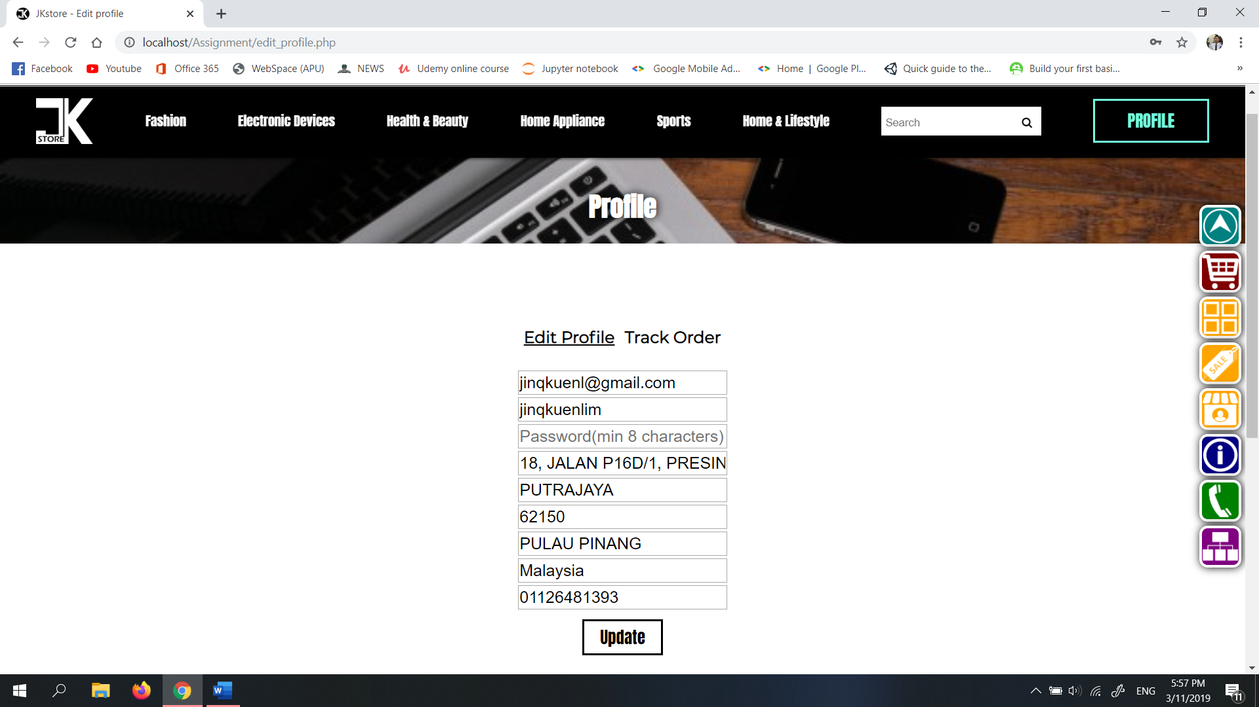

Diagram 6.12.2: Edit profile (2)

After filling the correct password, the users can start editing their information by changing the details and click update afterward.

## 6.13 Track order (buyer)

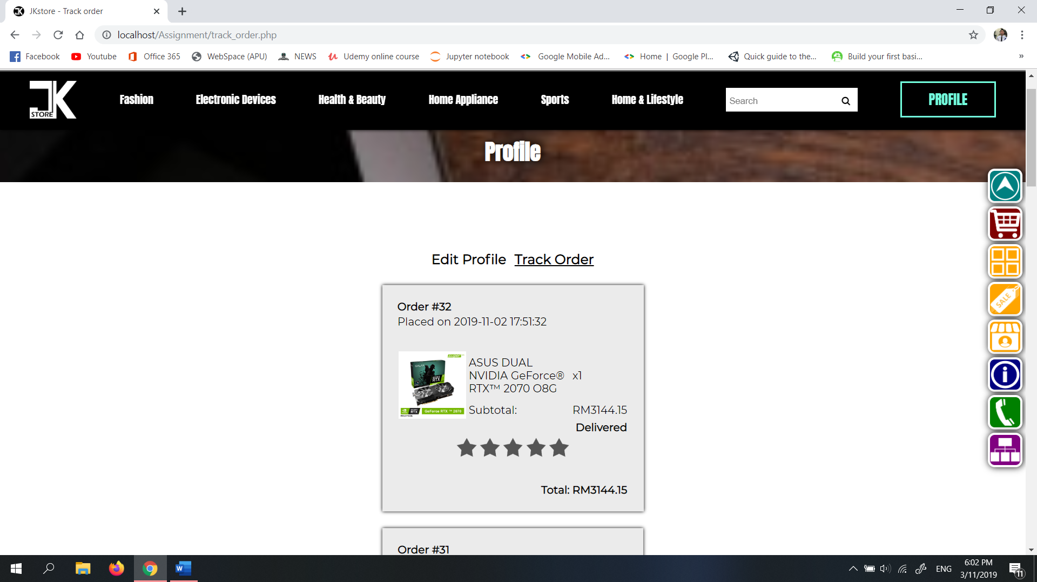

Diagram 6.13: Track order page

In this page users can preview their paid orders. And even rate for the products that have delivered.

## 6.14 About us page

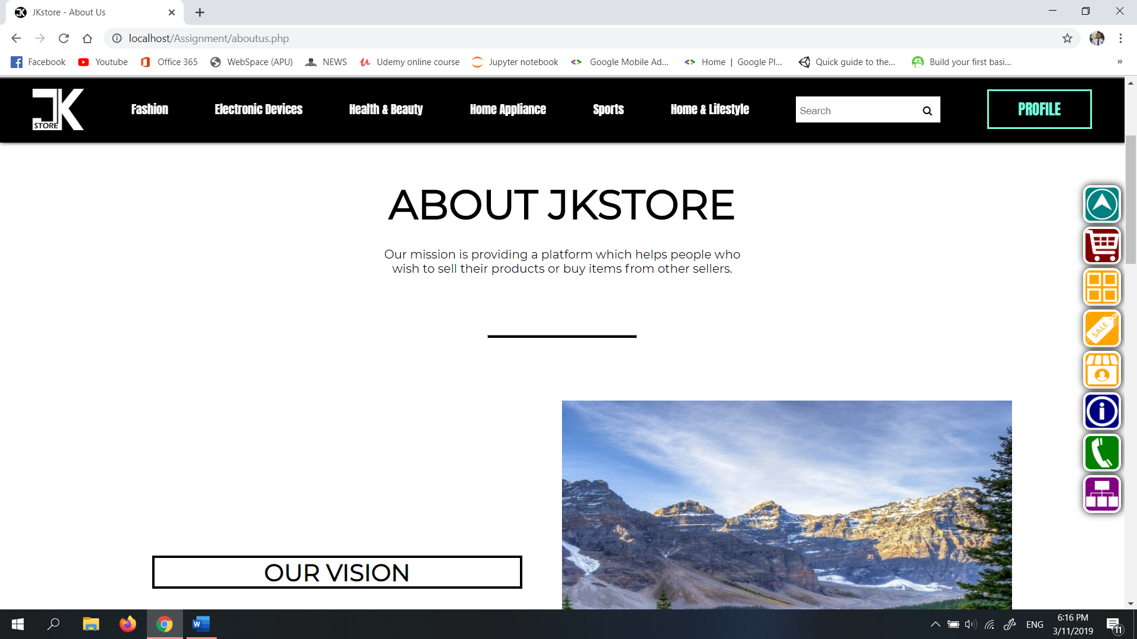

Diagram 6.14: About us page

This page is all about the information of JKstore.

## 6.15 Help and contact page

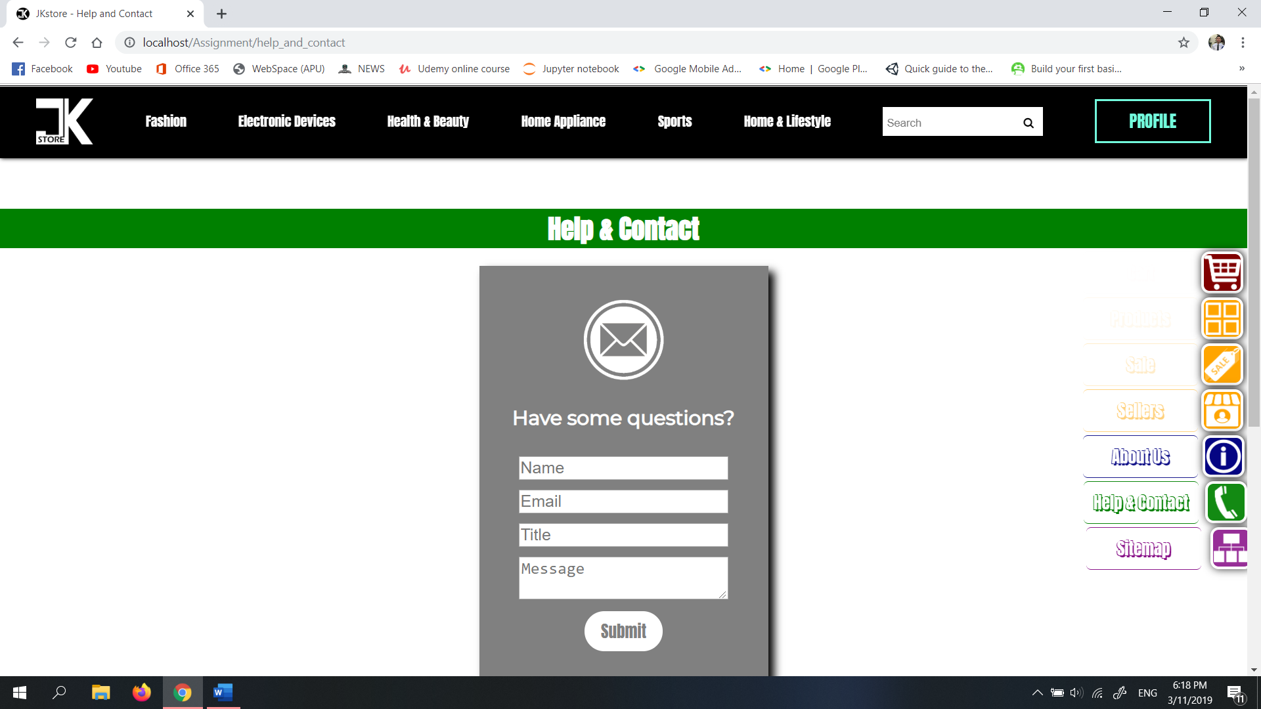

Diagram 6.15: Help and contact page

This is the page which users can submit their queries to admin.

## 6.16 Home page (seller)

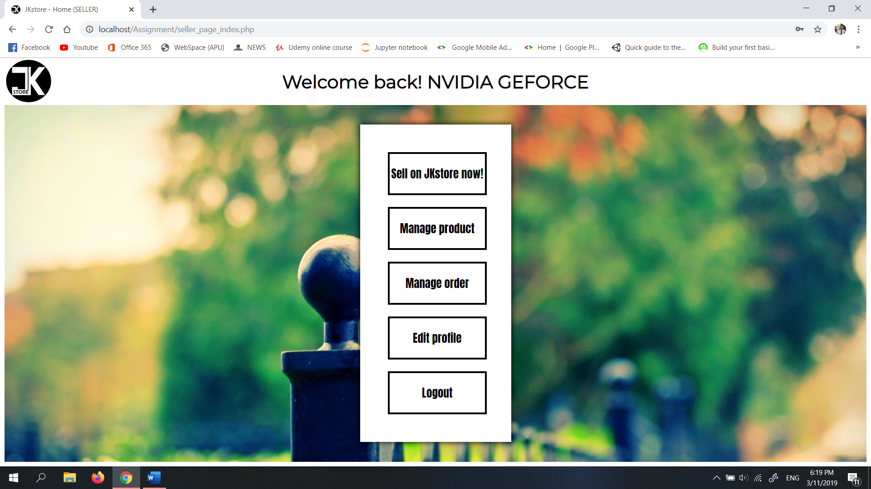

Diagram 6.16: Home page (for sellers)

This is the home page that sellers redirected to after login. Once they have logged in they can’t go to buyer webpages.

## 6.17 Selling page (seller)

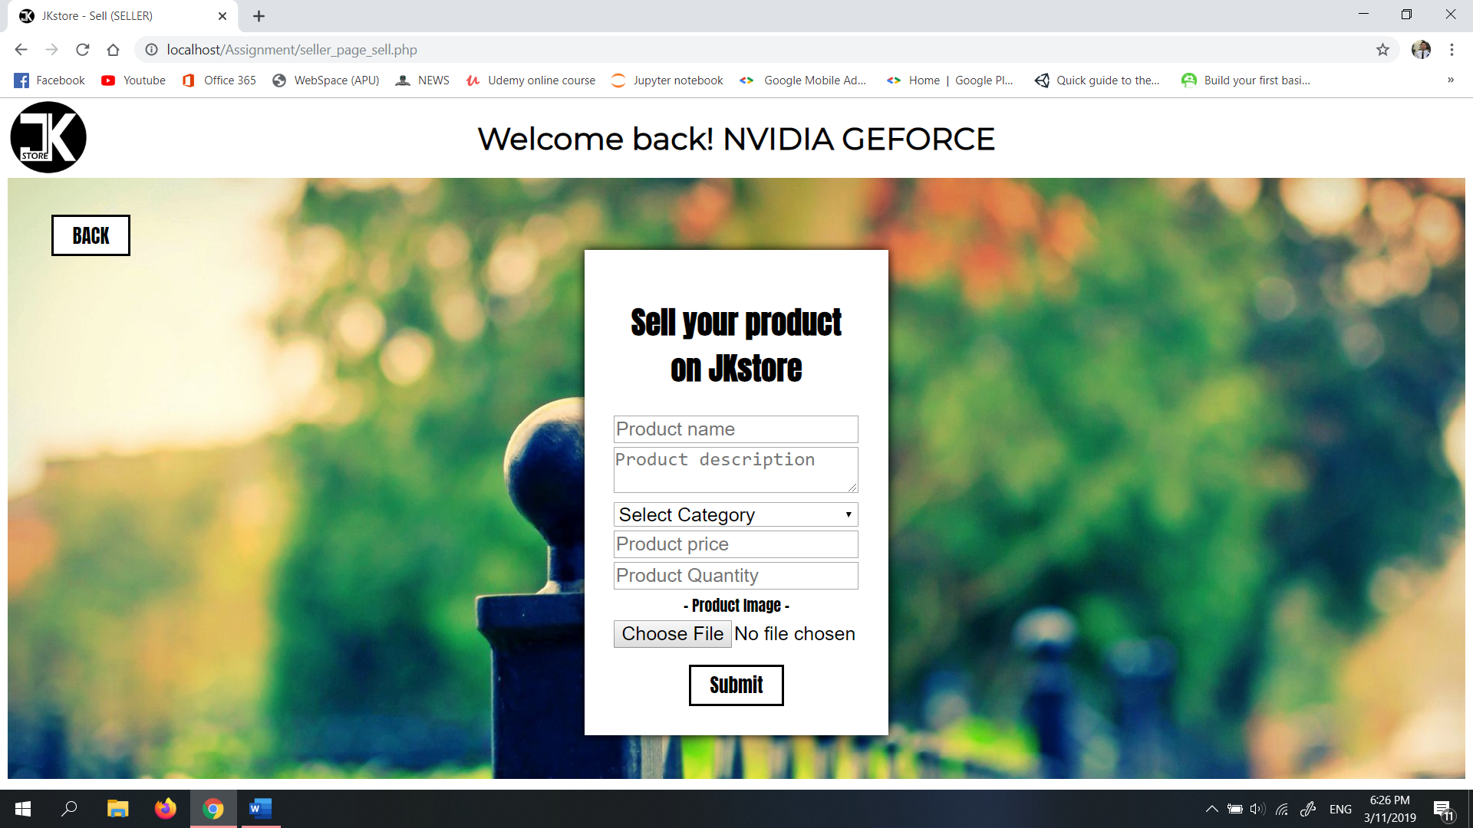

Diagram 6.17: Selling page (seller)

This is the page where seller can upload and start selling their products.

## 6.18 Manage product page (seller)

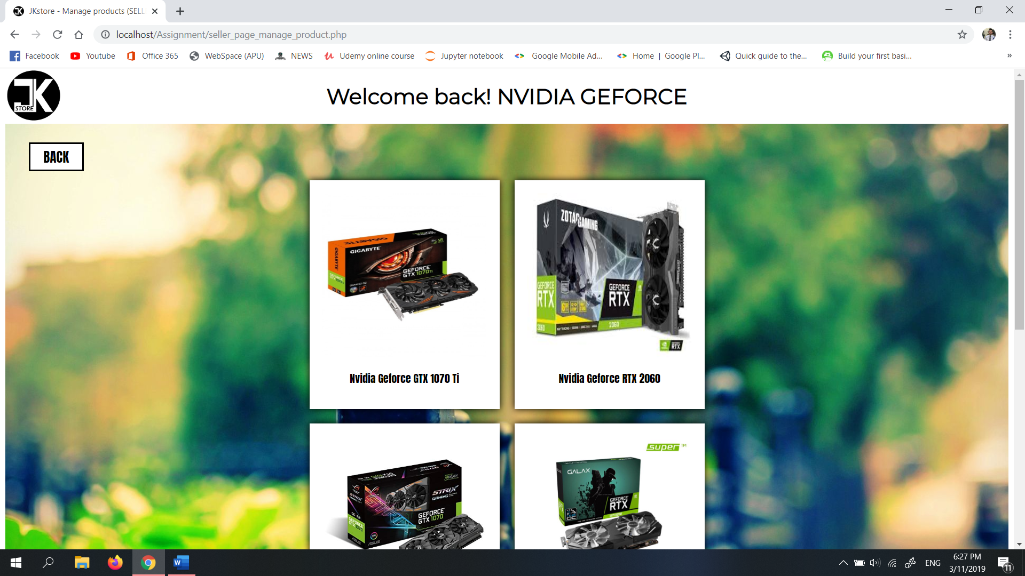

Diagram 6.18.1: Manage product selection page

The sellers get to choose which their existing products want to edit and manage in this page.

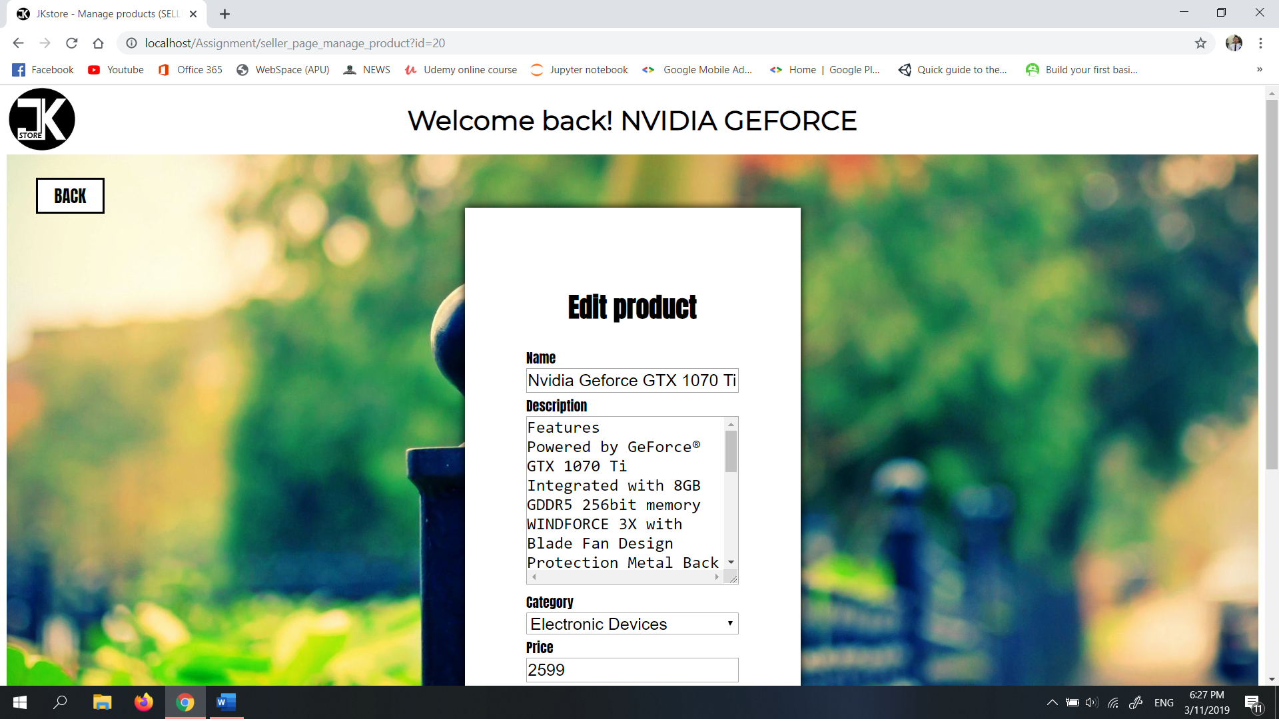

Diagram 6.18.2: Manage product edit page

In this page, the sellers can edit the details for their chosen product in diagram 66.

## 6.19 Manage order page (seller)

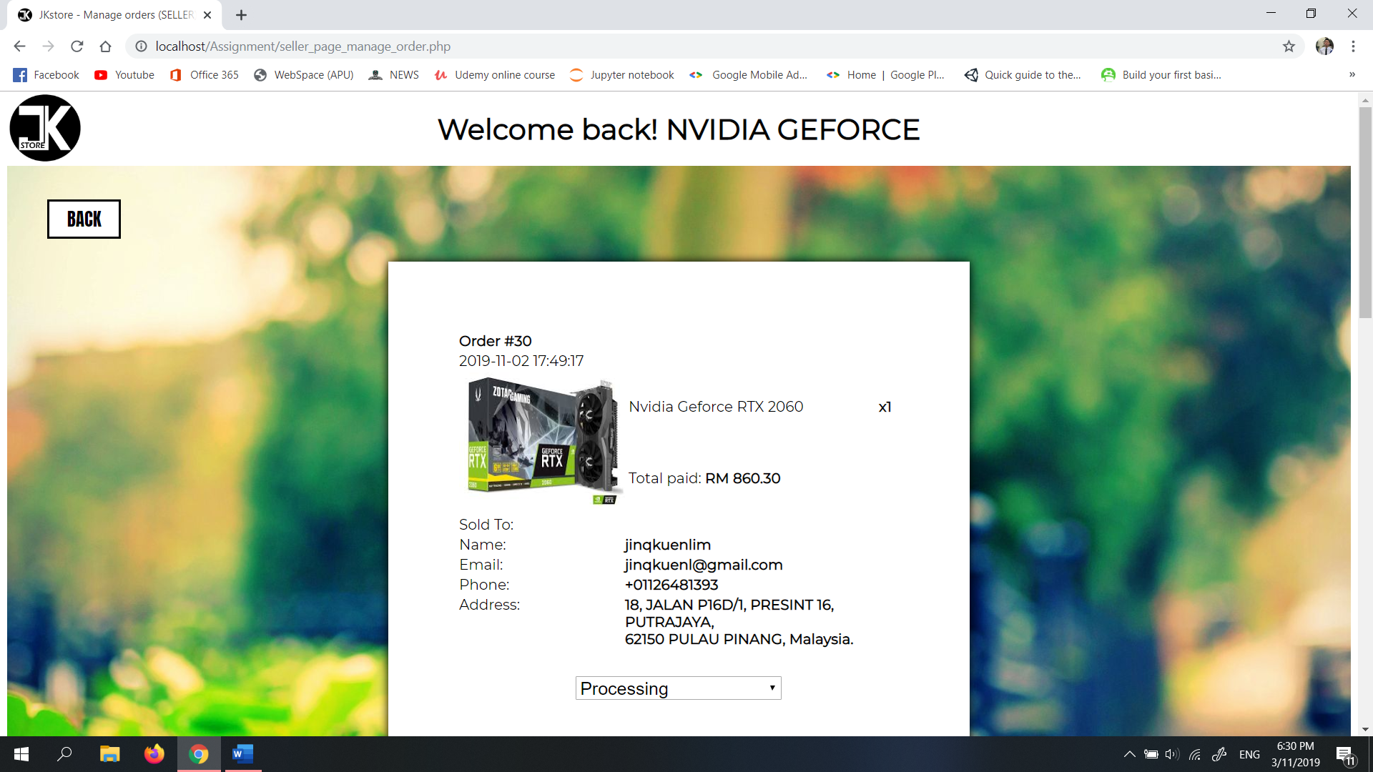

Diagram 6.19: Manage order page

Sellers get to update the shipping status for the buyers who bought their products.

## 6.20 Home page (admin)

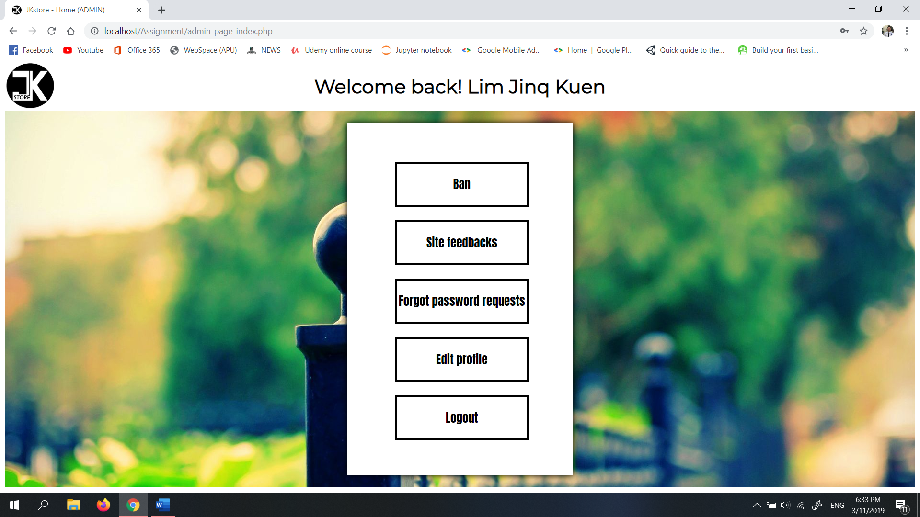

Diagram 6.20: Home page (admin)

This home page is specified for admin only.

## 6.21 Ban page (admin)

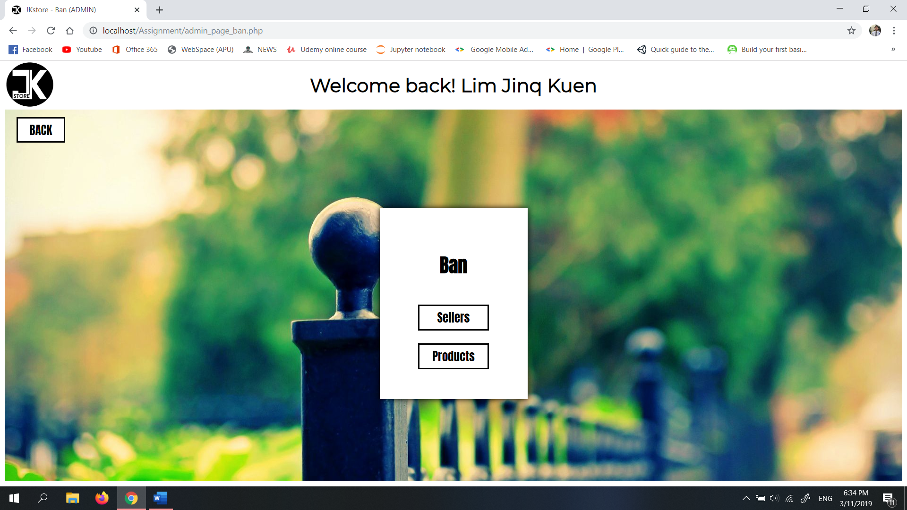

Diagram 6.21.1: Ban selection page

In this page, admin get to choose either sellers or products list displays.

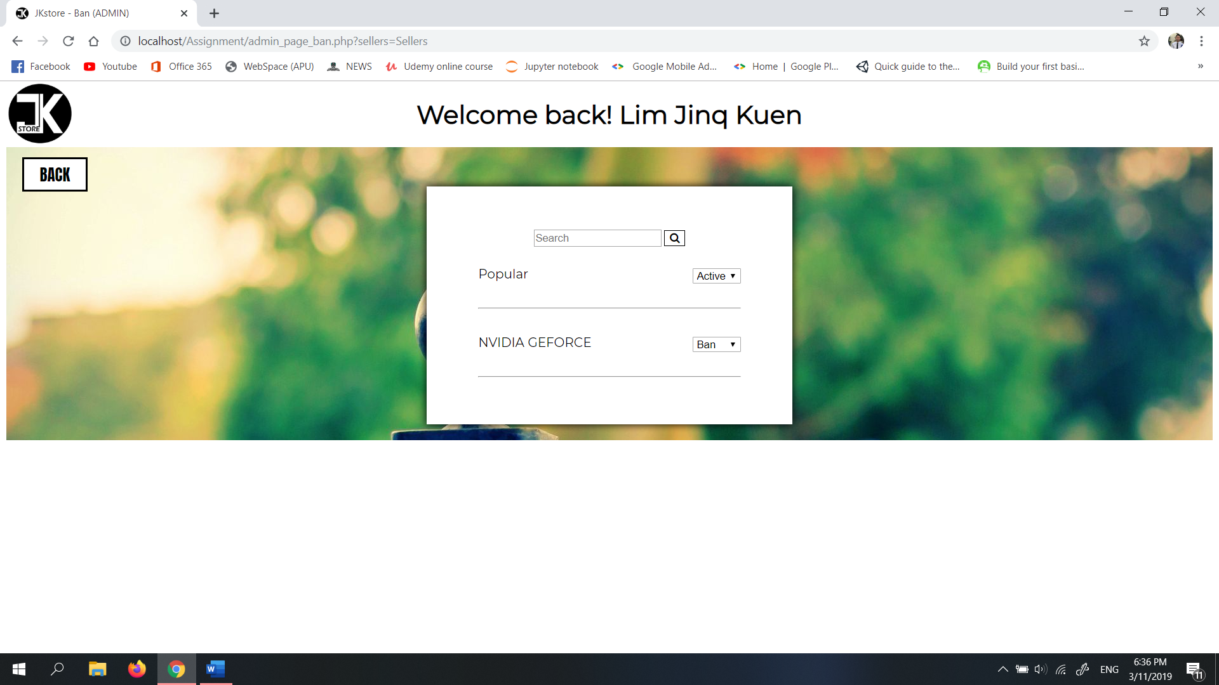

Diagram 6.21.2: Seller/ products list page

In this page, admin can ban or activate a banned seller or products.

## 6.22 Site feedback page (admin)

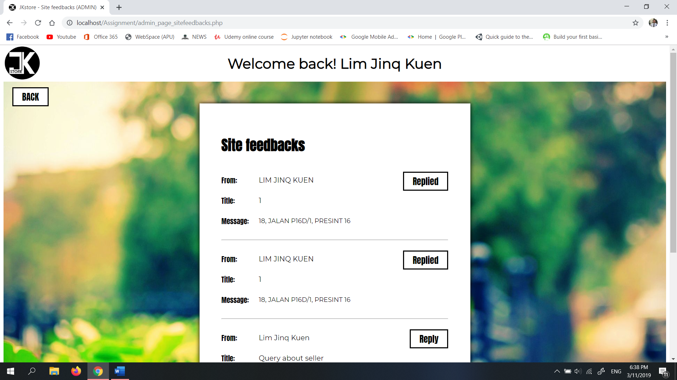

Diagram 6.22: Site feedbacks preview

Admin can preview and reply the queries or feedbacks given by other users.

## 6.23 Forgot password requests page (admin)

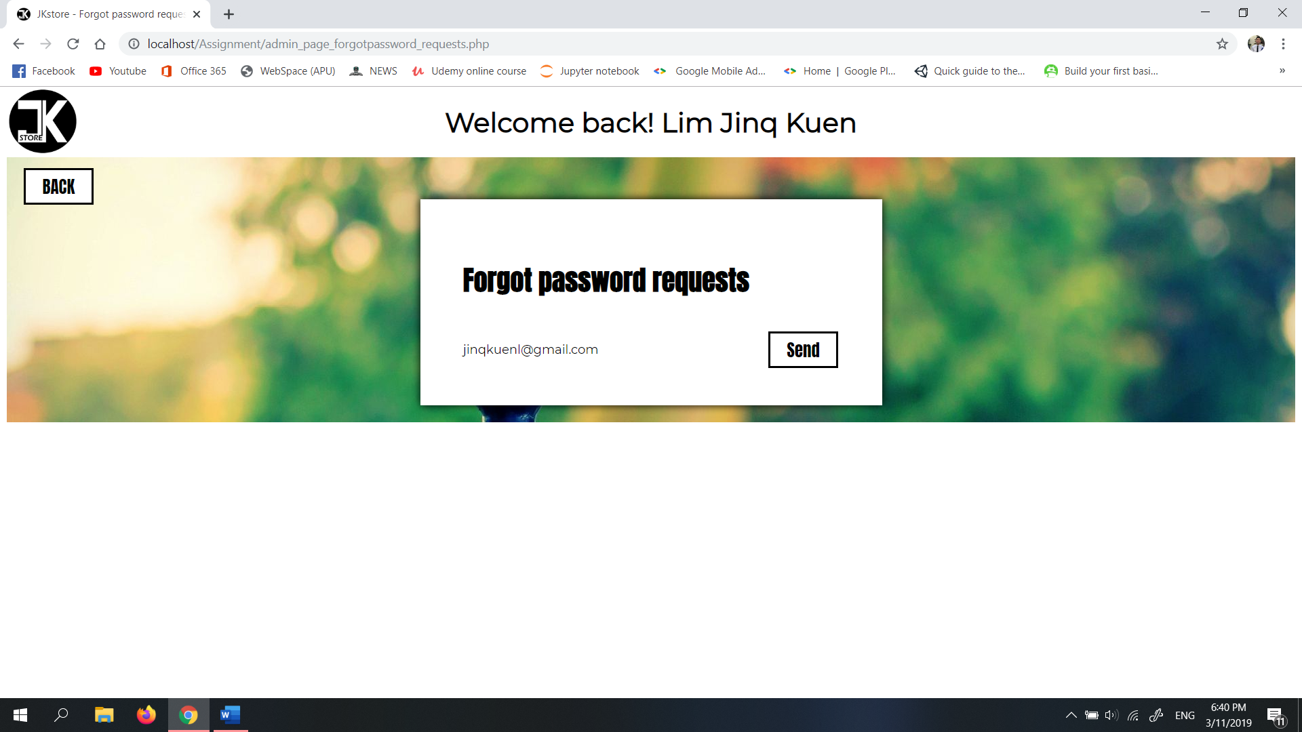

Diagram 6.23: Forgot password request page

Admin can see who has requested for resetting password and send them a reset password link.

# **7.0 References**

Pawar, S., 2018. *8 Principles of Good Website Design.* [Online]   
Available at: https://wpastra.com/good-website-design/  
[Accessed 2 November 2019].

Security Innovation Europe, 2016. *WHAT IS THE DIFFERENCE BETWEEN HASHING AND ENCRYPTING.* [Online]   
Available at: https://www.securityinnovationeurope.com/blog/page/whats-the-difference-between-hashing-and-encrypting  
[Accessed 2 November 2019].

w3schools.com, n.d.. *PHP Introduction.* [Online]   
Available at: https://www.w3schools.com/php/php_intro.asp  
[Accessed 3 November 2019].

w3schools.com, n.d.. *PHP Sessions.* [Online]   
Available at: https://www.w3schools.com/php/php_sessions.asp  
[Accessed 2 November 2019].